24 Intersection and Signal Control

24.1 Approaches to Intersection Design

24.2 Intersection Spacing and Rationalization

24.2.1 Identify Existing Bottlenecks

24.3 Grade Separation

24.3.1 Criteria for Grade Separation

24.3.2 Design Options

24.4 Restricting General Traffic Turning Movements

24.4.1 Evaluating Need for Turning Movement Restrictions

24.4.2 Alternatives for Restricting General Traffic Movements

24.5 Busway Turning Movements

24.5.1 Dedicated Turning Lanes and Additional Signal Phases for BRT Vehicles

24.5.2 BRT Vehicles Operating in Mixed-traffic Turning Lanes

24.5.3 BRT Turning Movements Prior to the Intersection

24.5.4 Queue-jump Signalization for BRT Vehicles (Pre-signals)

24.5.5 BRT Lanes at Roundabouts

24.6 Station Location Relative to Intersection

24.6.1 Locating the Stations at the Intersection

24.6.2 Locating the Stations away from the Intersection

24.6.3 Locating the Station Midblock between Intersections

24.6.4 Calculations for Optimizing the Location of Stations

24.6.5 Locating the Station under or over the Intersection (Grade Separation)

24.7 Traffic Signal Control and Intersection Layout

24.7.1 Traffic Signal Control

24.7.2 Intersection Layout

24.7.3 Intersection Capacity Analysis

24.7.4 Location of Detection Loops

24.7.5 Signal Priority

24.7.5.1 Passive Signal Priority

24.7.5.2 Active Signal Priority

24.7.6 Special Turn Movements Using Vehicle-activated Signals

24.7.7 Pedestrian and Cyclist Crossing Considerations

BRT Standard: Intersection Treatments

All turns prohibited across the busway 6 Points

Most turns prohibited across the busway 5 Points

Approximately half of the turns prohibited across the busway and some signal priority 4 Points

Some turns prohibited across the busway and some signal priority 3 Points

No turns prohibited across the busway but signal priority at most or all intersections 2 Points

No turns prohibited across the busway but some intersections have signal priority 1 Points

No intersection treatments 0 Points

# **Intersections and Signal Control**

*A bland smile is like a green light at an intersection, it feels good when you get one, but you forget it the moment you're past it.*

-Douglas Coupland

**Overview**

The objective of this chapter is to equip the traffic engineer with the tools required to optimally design the layout and operation of intersections along the proposed BRT corridors. Intersections are points where BRT vehicles can incur significant delay; they are also points where the BRT has the most critical impact on mixed traffic.

An important strategy to improve the performance of intersections to better accommodate public transport and other vehicles is to restrict general-traffic turning movements at intersections. *The BRT Standard* awards up to 6 points for good handling of BRT movements through intersections, with the most points given to systems which prohibit all turns across the busway.

Besides the above, this chapter also discusses the treatment of public transport vehicle turning movements, followed by a discussion of the placement of stations relative to intersections along the corridor. Finally, traffic-signal controlled intersections, their physical layout, the placement of traffic signal equipment, and techniques to provide public transport vehicles with priority at these junctions are discussed in more depth.

**24.1 Approach to Intersection Design**

*“Every doorway, every intersection has a story.”*

- Katherine Dunn, novelist, 1945 -

Even instersections alone are usually less critical than stations, they represent a critical point along any BRT corridor (Figure 24.1). A poorly designed intersection or a poorly timed signal phase can substantially reduce system capacity and speed, specially by hindering stations. Finding solutions to optimizing intersection performance can do much to improve system efficiency. Generally, the three main objectives of intersection design along a BRT corridor are to:

1. Minimize delay for BRT vehicles;
2. Provide safe and convenient crossings for pedestrians;
3. Minimize delay for mixed traffic.

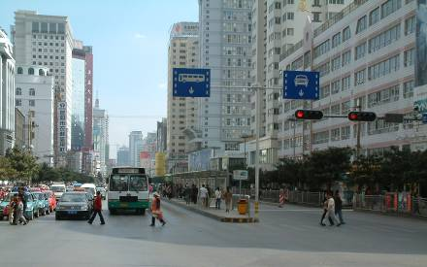

Fig 24.1 Intersection design affects the BRT system’s efficiency, pedestrian safety and access, and flows of mixed traffic vehicles. Photo by Lloyd Wright.

It is generally not advisable to use a standard intersection configuration throughout a BRT corridor. Rather, it is best to design the intersection for the specific conditions at the given location. The impact of a planned BRT system on overall intersection performance is often a significant consideration when deciding on a service plan for the BRT system, the location of the stations, and the design of the stations.

BRT system planners have tended to approach intersections in the following manner:

* Simplify the BRT system’s routing structure and rationalize major and minor intersections along the routes chosen;
* Identify existing bottlenecks and resolve using standard engineering practice;
* Restrict as many mixed-traffic turning movements on the BRT corridors as possible;
* Optimize the location of the station relative to adjacent intersections;
* Optimize the signal phasing;
* In low-frequency BRT corridors, consider signal priority for public transport vehicles.

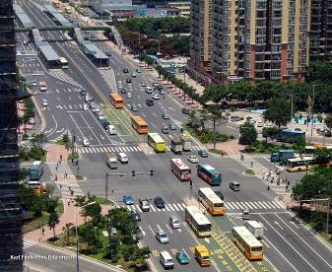

u-turn

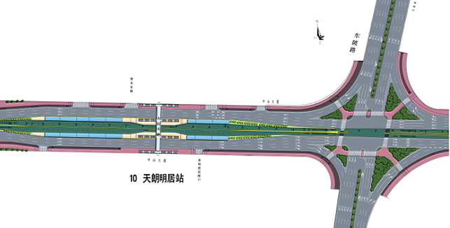

u-turn

Fig. 24.2 and 24.3 Typical major intersection on a BRT corridor in Guangzhou, China. Note at this intersection of the BRT corridor with Chibei Avenue, the station is located away from the intersection, and in order to turn left, the two-phase intersection requires a u-turn in the perpendicular road. Before the BRT, this four-phase intersection was a major traffic-congestion point. Photo by Karl Fjellstrom and intersection design by ITDP and GMEDRI.

Every decision and solution proposed during the intersection design process should be technically supported by the elaboration of a comprehensive traffic study, where classified and directional flow counts are carried out at every active intersection (signalized or not) along the corridor being designed. This is necessary to diagnose the current performance of each intersection and forecast a future scenario incorporating the operational changes a BRT corridor might bring.

**24.2 Bottlenecks**

*“Habit is the intersection of knowledge (what to do), skill (how to do), and desire (want to do).”*

― Stephen R. Covey

Bottlenecks are locations where peak-period congestion occurs on a daily basis, with long queues emanating from the point of constriction. These constrictions occur due to the roadway or intersection not having sufficient capacity to accommodate the flow, thus creating a congestion problem. The spillback of traffic and blockage of BRT lanes and contiguous intersections may ultimately impact BRT systems in dedicated lanes.

Once bottlenecks have been identified, data such as traffic-turning movement counts, traffic-signal phasing, and geometric layout (number, width, and turn-movement allocation of lanes) should be collected to be utilized in the capacity analysis of the intersection. In the case of Chirag Dilli in Delhi, India, poor intersection, operational, and station configuration have had major impacts on the BRT and traffic operations in the corridor, which are still unresolved.

Mixed-traffic movements and its eventual congestion should remain external to BRT lanes and its operation.

**24.3 Grade Separation**

*“Look at all the buses now that want exact change, exact change. I figure if I give them exact change, they should take me exactly where I want to go.”*

George C. Wallace

**24.3.1 Criteria for Grade Separation**

Exclusive busway use of a flyover or underpass can be a successful technique to expedite trips on a BRT corridor and is used in several existing BRT systems. The main concern is to provide convenient pedestrian access to these stations. Flyovers can also have major adverse visual impacts, from an aesthetics standpoint, in cities and urban areas.

In situations where grade separations are necessary, effective pedestrian access as well as visually neutral solutions can be designed. For TransMilenio Phase II’s “Avenida Boyacá” station along the Avenida Suba Corridor, the adopted solution was to locate the station above Avenida Boyacá, level with the flyover. Pedestrians access the platform via an elevator from a small pedestrian plaza where fares are collected. This solution allowed for the strategic location of this station, which will make future transfer points on the projected Av. Boyacá closer from each other. Ultimately, the implementation of solutions of this sort will depend on budgetary constraints.

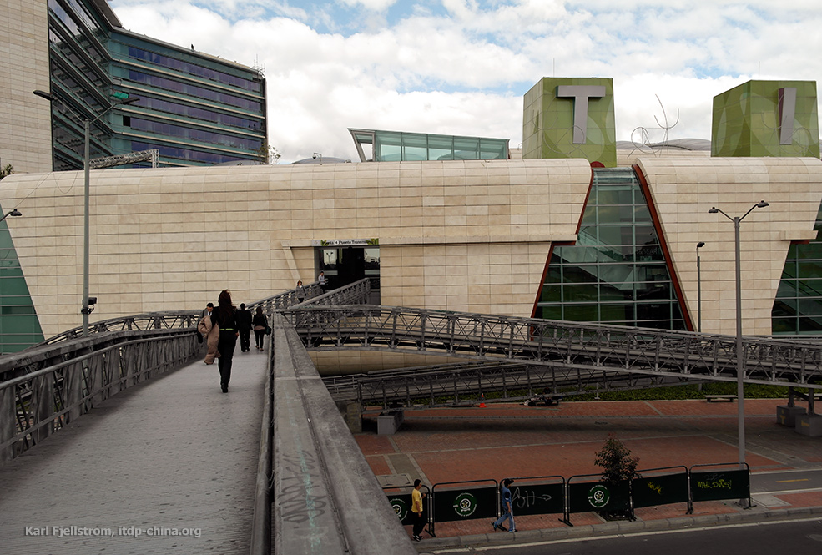

Fig. 24.4 The Boyacá BRT Station in Bogotá is on the flyover and also connects to the second floor of a new mall through a pedestrian bridge. Photo by Karl Fjellstrom.

**24.3.2 Design Options**

Grade separation at major intersections or roundabouts can be considered in the following ways:

* On the crossing road for general traffic (Option 1);
* On the major route for BRT vehicles only (Option 2);
* On the major route for general traffic only (Option 3);
* On the major route for BRT and general traffic (Option 4).

For Options 1 and 2, no special difficulties are introduced from a traffic perspective; and both can help to decongest a BRT intersection and increase green-phase time.

For Option 3, if a single flyover median is built for two-way general traffic and buses are forced to use surface streets, the buses in the median must cross general-traffic lanes going over the flyover (Figure 24.5). If, however, for Option 3, two separate flyovers are constructed, one for general traffic in each direction, leaving a space between the flyovers for the BRT system, which allows the BRT buses to continue along the surface, then the problem highlighted above is avoided.

Option 4 allows the BRT and general traffic to pass over the flyover either in segregated lanes or in mixed traffic (Figure 24.6).This option can result in BRT stations being located far apart. This option is particularly problematic if there is a connecting BRT corridor on the crossing road below the flyover.

While the discussion in this section has concentrated on flyovers as a means of grade separation, underpasses are frequently the preferred option from an aesthetics standpoint. However, subsurface conditions, including the presence of services (utilities) and/or high water tables and hard-rock conditions, may result in underpasses not being technically feasible or economically viable.

Generally, the cost of a busway on a flyover will be at least ten times the cost of a normal at-grade busway. The cost of a busway in an underpass will be similar to that of a flyover, unless there are adverse subsurface conditions which could drive up costs significantly.



Fig. 24.5 Schematic of Delhi’s roadway in which BRT vehicles must cross mixed traffic that is attempting to access a flyover. Diagram courtesy of ITDP.

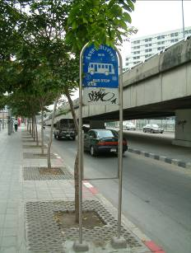

Fig. 24.6 While mixed-traffic vehicles can bypass a congested intersection in Bangkok, Thailand, public-transport vehicles are often consigned to serving stations near the intersection. The result can be slow average speeds for public transport. Photo by Lloyd Wright.

**24.4 Restricting General Traffic Turning Movements**

*“Change means movement. Movement means friction. Only in the frictionless vacuum of a non-existent abstract world can movement or change occur without that abrasive friction of conflict.”*

- Saul Alinsky, political activist, 1909 – 1972

Maximizing a BRT system to handle the highest number of passengers is often at odds with maximizing the system operating speeds. From the point of view of achieving passenger demand to the system, it is best to have a lot of routes into the BRT system, reducing transfers and overall travel times, and for the BRT system to have a dense network of interconnected routes with high capacity and as few operational disruptions as possible. Station delays and intersection idle times are some of the main focal points for any BRT corridor optimization effort. For signalized-intersection analysis, general demand is determined by vehicle volumes transiting the intersection for each the movements allowed, and capacity is given by the allocation of necessary green time for each traffic-movement throughput. Consequently, having less required/allowed movements at the intersection translates into longer assigned green times for the principal flows and a higher level of service at the intersection. Intersection optimization should focus on reducing the number of active intersections or simplifying the allowed traffic movements at the intersection that are impossible to eliminate.

**24.4.1 Evaluating the Need for Turning Movement Restrictions**

A standard technique for increasing BRT travel speeds and reducing signal delay is to restrict as many mixed-traffic turning movements across the corridor as possible (Figure 24.7).If the busway is reaching saturation, or the introduction of the BRT system increases mixed-traffic saturation to critical levels, it becomes imperative to consider some form of turning restrictions with the objective of achieving an ideal two-phase intersection.

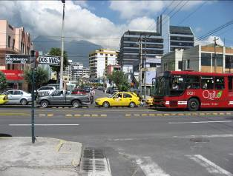

Fig. 24.7 Prior to Quito’s Ecovía line, mixed-traffic vehicles were allowed to cross through this intersection as well as negotiate right and left turns. To give priority to public transport, straight and left turn movements have been blocked. Photo by Lloyd Wright.

**24.4.2 Alternatives for Restricting General Traffic Turning Movements**

The restriction of turning movements is generally done by eliminating the left-turn movements (or right turns for left-hand circulation) for general traffic at the intersection in the following ways:

Option 1: By means of a u-turn at a median break downstream of the crossing road, followed by a right turn at the crossing road. As this movement crosses the bus lanes, undesirable conflicts may be created for the BRT system (Figure 24.8), though this configuration can be very successfully applied to BRT station access (.

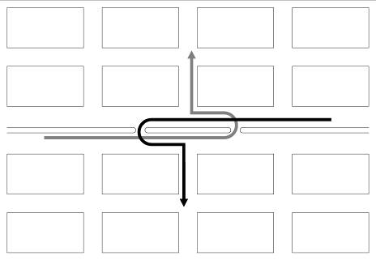

Fig. 24.8 Left turns for mixed-traffic vehicles are accomplished via u-turns along the busway. Diagram courtesy of ITDP.

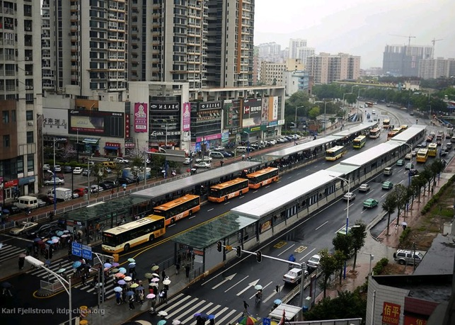

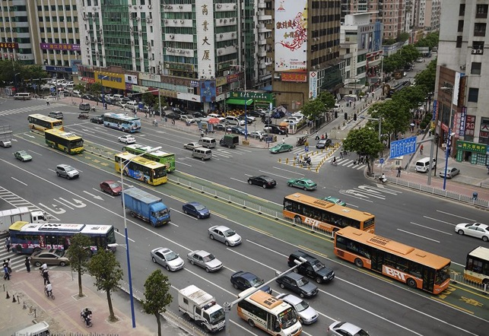

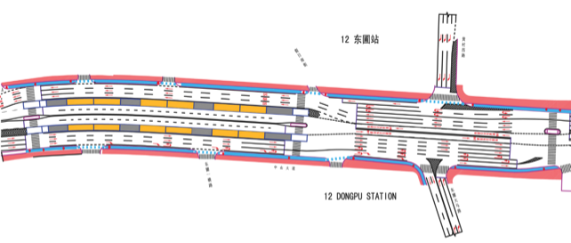

Figures 24.9, 24.10, and 24.11: Dongpu BRT station in Guangzhou, China provides at-grade station access at both ends, combined with u-turns. This intersection was previously a major traffic blackspot—a location where traffic accidents have often occurred—but now works very smoothly for all modes, with a two-phase signal combined with u-turns and pedestrian crossings, including BRT station access. Photos by Karl Fjellstrom and design by ITDP with GMEDRI.

Option 2: By means of a right turn at the crossing road, followed by a u-turn in the crossing road at a suitable location approximately one hundred meters from the major route. The crossing-road width would have to be sufficient to accommodate the u-turn (Figure 24.12 and Figure 24.3).

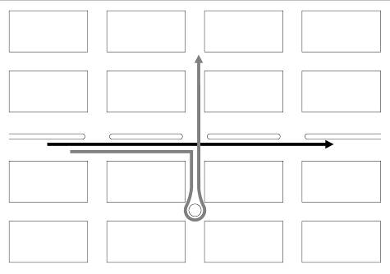

Fig. 24.12 Left turns for mixed-traffic vehicles are accomplished via u-turns along the crossing road. Diagram courtesy of ITDP.

Option 3: By means of a right turn at the street, one block after the crossing road followed by two successive right turns (Figure 24.13).

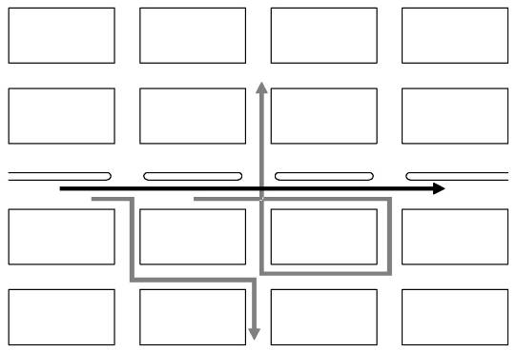

Fig. 24.13 Left turns for mixed traffic are accomplished via “round–the-block” routing after the intersection. Diagram courtesy of ITDP.

Option 4: By means of a right turn at the street, one block before the crossing road, followed by two successive left turns. (Figure 24.14)

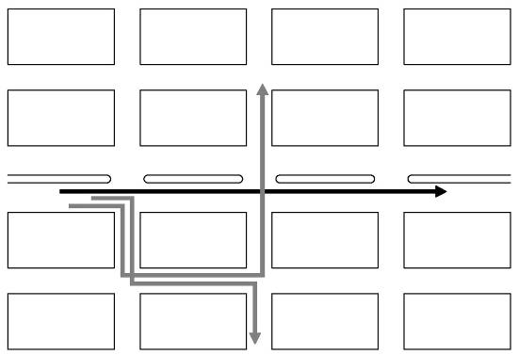

Fig. 24.15 Left turns for mixed traffic are accomplished via “round–the-block” routing prior to the intersection. Diagram courtesy of ITDP.

Option 5: By means of a u-turn movement followed by a right turn at the crossing street (similar to Option 1 on this list). U-turn facilities to be constructed after the intersection for cases where “around–the-block” (options 3 and 4) solutions are difficult or impossible to implement, and traffic is already too congested on the crossing street to implement the changes in Option 3. Ideally, phases in both intersections should be coordinated to avoid excessive delays. Queuing areas for turning vehicles should be carefully calculated to satisfy the demanded capacity (Figure 24.15).

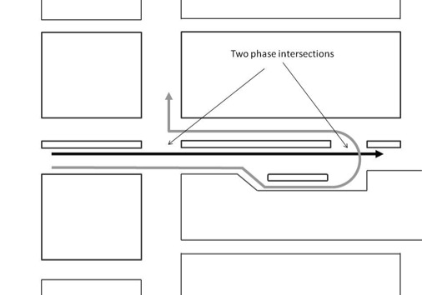

Fig. 24.15 Left turns for mixed traffic are accomplished via u-turn facilities constructed after the intersection. Diagram courtesy of ITDP.

There are other similar combinations of movements in the adjacent street system which could also be considered. These options, however, all assume/presume that an adjacent secondary-street system exists and has the capacity to absorb additional traffic caused by the proposed diversions. In a suburban situation, particularly when the adjacent land use is primarily residential, there is likely to be considerable resistance to the above proposals.

Alternatives to restricting general-traffic turn movements at the intersection are: (1) provide separate, protected turn lanes and phases for general-traffic turn movements crossing the bus lanes (provided the road-reserve width is adequate); (2) provide a pre-signal to give BRT vehicles the opportunity to get to the front of the queue at the intersection where road-reserve widths are constrained (see section 24.5.4. queue-jumping)

**24.5 Busway Turning Movements**

*“An Englishman, even if he is alone, forms an orderly queue of one.”*

- George Mikes, writer, 1912 - 1987

While route simplification and organization may to an extent minimize turning movements for BRT vehicles by placing them in the same locations, turning is necessary and desired. By developing BRT routes with turns, easy platform transfers for the customers are made possible and sometimes not even necessary. Thus, turning movements by BRT vehicles shall be an integral part of designing an effective overall route structure. As the BRT system expands and provides an increasingly dense network of lines, the connections between these lines become more complex. As BRT systems grow, there will be a growing number of BRT trunk corridors that cross one another.

The costs of not allowing turning movements by BRT vehicles are quite evident, especially in terms of customer convenience. Quito’s three BRT corridors (Trolé, Ecovía, Metrobus-Q) all operate as independent corridors, despite each intersecting one another at several points in the city. At one of the critical intersections between two intersecting BRT corridors in Bogotá (Caracas and Jimenez), customers must transfer by negotiating passages through stairs and an underground tunnel (Figures 24.17 and 24.18). In both these examples, allowing turning movements by the BRT vehicles could have permitted simpler and more convenient platform transfers for the customer. Furthermore, the cost of constructing connecting pedestrian tunnels can add much to the overall infrastructure costs of the system. This is copying the bad parts of rail systems. In the Bogotá situation, customer convenience has been significantly increased by allowing turn movements and direct transfers between the Caracas and Jimenez corridors.

|  |  |
| --- | --- |
| DSCF0803 | Bogotá, Colombia, Jimenez-Caracas tunnel, Dec 2003 |

Fig. 24.16 and 24.17 A tunnel is used to connect two intersecting corridors in Bogotá. However, for many, making a transfer of this type imposes physical hardship. Photos by Lloyd Wright.

In order to facilitate transfer-free travel or even platform transfers, BRT turning movements from one corridor to another are desirable.

However, as will be discussed below, by restricting private-vehicle left turns, then all BRT turning movements can be handled by a simpler three-phase signal system. Alternatively, limiting the number of turning permutations for BRT vehicles can help eliminate any conflicts with turning private vehicles. By adding a dedicated turning lane for BRT vehicles, the problem of turning congestion can also be resolved.

There are several solutions to allow BRT vehicles turning that avoid consuming much of intersection capacity – mostly needed for cars in that intersection – and the appropriate solutions will depend on the budget available, right-of-way available, the number of vehicles in the BRT system and their turning volumes, and the level of mixed traffic and its turning volumes. *The optimal solution will be location specific and it is recommended that each intersection be evaluated and optimized separately.* There are five main options for busway turning movements: (1) Dedicated turning lanes and additional signal phases for BRT vehicles; (2) BRT vehicles operating in mixed traffic turning lanes; (3) BRT turning movements prior to the intersection; (4) Queue jump signalization for BRT vehicles (pre-signals); (5) Grade separation (6) transform the crossing in a roundabout.

**24.5.1 Dedicated Turning Lanes and Additional Signal Phases for BRT vehicles**

A dedicated turning lane for BRT vehicles has the advantage of keeping the BRT vehicles in a controlled space at all times. (Figure 24.18) This arrangement may require an additional signal phase if there was no previous left-turn phase. Otherwise, the dedicated turn would take place at the same time that the mixed traffic is allowed to turn left.

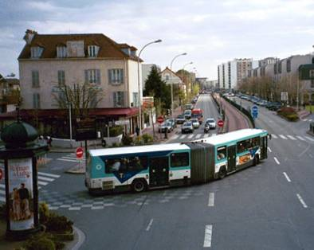

Fig. 24.18 The green phase for a BRT vehicle entering the Val de Marne busway in Paris. Photo courtesy of the National Bus Rapid Transit Institute (NBRTI).

Possibly the greatest challenge to this configuration is finding the physical space to place the additional turning lane. The roadway would likely have to accommodate at least five lanes (Figure 24.20). If two lanes of mixed traffic in each direction are to be maintained for straight-car movements, then seven lanes of roadspace would be required.



Fig. 24.19 Configuration for a system with a fully dedicated BRT turning lane. Diagram courtesy of ITDP.

The configuration suggested in Figure 24.19 would require a three-phase traffic signal, as indicated in Figure 24.20.



Fig. 24.20 In order to permit the BRT turning movements suggested in Figure 24.15, a three-phase traffic signal would be required. Diagram courtesy of ITDP.

In this case, it is important to note that not all turning permutations need to be provided for the BRT system. Instead, only one turn from each corridor to the other is required to give full access to all route permutations. This flexibility occurs due to the existence of a single-median station. A southbound vehicle turning left will give passengers access to both the eastbound and westbound routes. Eastbound passengers will simply remain on board and continue along the corridor. Westbound passengers will undergo a platform transfer at the first station and reverse direction with a westbound vehicle. In designing this option, one would choose the highest demand routes to receive the transfer-free routing.

In this scenario, one could technically also allow left-turn movements for mixed-traffic vehicles for traffic from north and south , but even more additional lanes would be required. Ideally though, mixed traffic should be diverted as proposed in the section above (24.4 Restrictions to mixed-traffic turn-movement) as the BRT left turn phase will be usually very short (like the queue-jumping phase). This short phase can even accommodate right-turns from north and south as BRT vehicle's drivers can negotiate entrance in the west-east corridor, if the volumes are low enough

The complexity of dedicated turning lanes obviously increases as turning options for both BRT vehicles and mixed-traffic vehicles increase. In the extreme of permitting all BRT turning options and all mixed-traffic turning options, then a total of six traffic-signal phases would be required (Figure 24.21).This number of phases clearly holds disadvantages in terms of waiting times for both BRT and mixed traffic-movements and reduces capacity of the intersection so drastically, that is very likely to be unfeasible in a location where to important corridors cross each other.

Fig. 24.21 To permit a full range of both BRT and mixed-traffic turning movements, a total of six signal phases would be required. Diagram courtesy of ITDP.

Move around in this Jakarta intersection of 2 corridors with Google Street View:

(https://www.google.com.br/maps/@-6.167649,106.821039,3a,75y,6.35h,84.17t/data=!3m6!1e1!3m4!1s1FyI5G400U8kbl18-AolUw!2e0!7i13312!8i6656!6m1!1e1)

(if link is broken: Jalan Majaphit X Jalan Veteran in Jakarta DKI)

**24.5.2 BRT Vehicles Operating in Mixed-traffic Turning Lanes**

n this scenario, all turning BRT vehicles must leave the dedicated busway and enter mixed-traffic lanes. Thus, a left-turning BRT vehicle will leave the busway and directly enter the left-turn lane for cars. A right-turning BRT vehicle must leave the busway and merge to the right of the street. Once the turning BRT vehicles have left the intersection area they re-enter a busway.

This technique is the most common solution that has been used in many of the “open” BRT systems like in Kunming, China, and is being planned on several “direct services” BRT systems (Figure 9.35). If there is no physical separation of the busway, the merge with the mixed traffic can happen anywhere in the proceeding block. If there is physical separation, it must occur at the previous intersection, or a slip lane must be provided.

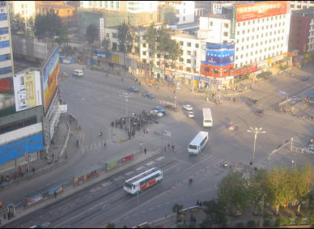

In Kunming, turning BRT vehicles leave the busway and enter a mixed-traffic lane to finalise the turning movement. Photo courtesy of ITDP.

From a signal phase standpoint, this option is the easiest to implement, as it does not require changing the signal phase, and does not require any major new infrastructure. However, this option does present a serious disadvantage in terms of congestion delay for the turning BRT vehicles. Further, if the mixed-traffic congestion is heavy, the BRT vehicles attempting to turn may not be able to readily leave the busway, and thus can cause delays to all BRT vehicles, even those vehicles continuing in a straight routing. The BRT vehicle turning right has particular challenges since it must essentially cross all mixed-traffic lanes both before and after the intersection. Attempting these lane changes is particularly difficult if the system is using 18.5-metre articulated vehicles or 24-metre bi-articulated vehicles.

Any time BRT vehicles must leave exclusive busway operation and enter mixed-traffic lanes the system losses a certain amount of psychological status with the customer. Mixed-traffic operation makes the system much more akin to a conventional bus system rather than a highly-efficient mass transit system. Once vehicles start operating in mixed traffic, the customer’s “mental map” of the system becomes more uncertain. Such confusion does much to discourage system use by occasional and discretionary system users.

**24.5.3 BRT Turning Movements Prior to the Intersection**

To avoid having an special BRT turning phase in an main intersection, an alternative is to create a special bus-only turn (this is as good for left as to right turns) phase at a an intersection before a major intersection where there is less (or none) crossing demand than in the main crossing corridor (Figure 9.36). For a few blocks, the BRT vehicle will operate on secondary streets (in mixed traffic or on a dedicated lane) until it rejoins the busway. This option requires the availability of usable secondary streets and consideration regarding the placement and use of stations by turning routes (because an important intersection is often the origin/destiny of many trips)



**Figure 9.** In this scenario, the BRT turning movement is made prior to the main intersection. The BRT vehicle temporarily operates on the secondary road network.

**24.5.4 Queue-jump Signalization for BRT vehicles (Pre-signals)**

The signal system can be utilized to give BRT vehicles a head start on turning movements prior to private-vehicle turning movements. In this case, a dual traffic signal is utilized for each direction of travel. One traffic signal is located at the intersection, and another traffic signal is located approximately 30 to 50 meters prior to the intersection. At the traffic signal prior to the intersection, the BRT vehicles on the busway would receive a green signal of approximately 10 seconds prior to the green signal for the mixed traffic (Figure 24.24). During this head start, the BRT vehicle would be able to exit the busway and cross to the other side of the street. This is almost equivalent to having BRT vehicles in dedicated infrastructure with three phases with three-phases-signal (24.5.1).



Fig. 24.24 While mixed-traffic vehicles are held for an extra ten seconds at the first traffic-signal stop, BRT vehicles are given a queue-jumping head start. If headstart is given to both traffic bounds, BRT vehicle drivers will have to negotiate passage. Image adapted from TCRP.

**24.5.5 BRT Turning Movements with Grade Separation**

Another alternative is to provide the dedicated turns through grade-separated infrastructure. While grade separation can be a highly efficient mechanism for facilitating free-flow turning, it can also be costly. The time saved for BRT customers and mixed-traffic vehicles weighed against the cost of the underpass or flyover can justify the costs, when the volume of BRT buses are really high, as is the case of Bogotá's interchange between 80th Street and Norte-Quito-Sur Avenue interchange that utilizes both underpasses and overpasses to provide dedicated turning infrastructure to BRT operations (Figures 24.22 and 24.23).

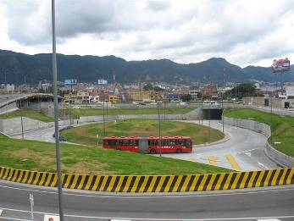

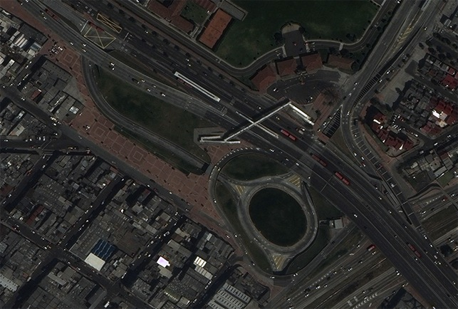

Fig. 24.22 and 24.23 At the major intersection of TransMilenio’s Calle 80 (80th Street) corridor and NQS corridor, a set of underpasses, a roundabout, and an overpass help facilitate exclusive turning movements for BRT vehicles. Top photo courtesy of Eduardo Plata and Por el País que Queremos (PPQ). Satellite imagery from Google Earth, from January 2011.

**24.5.6 Convert cross into a roundabout**

If the crossing corridors happens to be of two broad highways, enough right-of-way may be available to convert a standard four phase intersection into a two-phase signalized roundabout. This is a clever alternative that shall be remembered, as as in many developing-nation cities, such right-of-way is available but underutilised.

The exclusive BRT busway terminates approximately 50 metres prior to the intersection with the BRT vehicles entering mixed traffic at that point. This approach essentially turns the junction into a grid of one-way streets. It requires a fairly large amount of right-of-way at the junction.

Figure ??? indicates how the junction between two major boulevards can be turned into a two-phase traffic circle by creating a kind of mini-grid of one-way streets. At low traffic volumes, the BRT buses enter mixed traffic prior to the intersection. A series of queuing areas (marked as “A”, “B”, “C”, and “D” in Figure ???) help stage vehicle flows through the roundabout. This areas are referred as “waiting boxes”

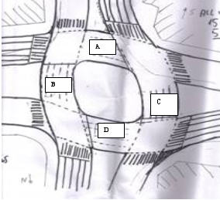

Figure 24.?? In this scenario, the intersection is converted to a roundabout with vehicle queuing areas at points “A”, “B”, “C”, and “D”. The BRT vehicles enter mixed traffic just before the intersection and move through the intersection with a two-phase signal.

Figure 24.?? outlines the vehicle movements for first signal phase for this roundabout conversion. This example is given from the perspective of a British-style road configuration. All east-bound BRT vehicles and mixed traffic vehicles that are making right-hand turns would pass through the intersection and queue in area “C” at a traffic light. All east- and west-bound traffic can proceed straight. All vehicles making left-hand turns can proceed. All west-bound traffic would pass through the intersection and queue in area “B”.



Figure 9.0 Vehicle movements for signal phase 1.

In the second signal phase, all northbound and southbound traffic can proceed straight, all left hand turns can proceed, and all right turning traffic would queue in areas “A” and “D” (Figure 9.39).



Figure 9.0 Vehicle movements for signal phase 2.

This solution will work up to the point where the amount of space in areas “A”, “B”, “C”, and “D” is sufficient to accommodate all the turning traffic. The required and available space are discussed in Box 24.1.

Opposite to the rule to increase capacity, cycle on a signalised roundabout of this type should be short, so the qeueing box can handle volumes (manual operators must be very carefull when handling these intersections, keeping eye in the queueing boxes to decide when to alternate to the next phase). Other alternatives of busways thru roundabouts are discussed in the next section.

------------------------

BOX24.1: Required and available space for queing boxes: Equations 9.5 and 9.6 define the calculations for the required and available queuing space.

A passenger-car unit, or pcu is a reference used to bring different vehicle types to a common denominator. The conversion factor from a certain type of vehicle to a passenger car unit depends of application intended after the conversion, being eventually calibrated for an specific use in an specific situation (for example if stress uppon the pavement or congestion potential is considered, if such is in urban environment or in a highway)

In any case, a motorcycle for example tends to have an equivalent of less than one vehicle, and a bus is equivalent to more than one vehicle.

For the purpose of evaluating queing space, we consider that:

- The ammount of road space a passenger-car practically uses is 15 square meters, this includes some distance kept vehicls keep from each other when queueing on the traffic light (Area_pcu = 15 m²);

- The ammount of road space needed for a 12 metre-bus to queue is 30 square meters, there fore its equivalence factor is 2.0, i.e. one 12 metre-bus uses twice the space a cpu;

- An articulated BRT vehicle has an equivalent factor of 3.5 cpu;

Therefore the available area capacity and the required area (or demanded area) to transform a cross into a round about are:

Equation 24.1 Available Capacity of queueing box

AvailableCapacity_queue-box = Area_wait-box / Area_pcu

where:

AvailableCapacity: number of cars that fit in wait-box (in pcu)

Area_wait-box: ammount of space in the wait box (either A, B, C or D in Figure 24.???)

Area_pcu: ammount of road space a passenger-car uses = 15 m² (it should be expressed in the same unit of area_wait-box, obviously)

Equation 24.2

RequiredCapacity_wait-box = Flow_left-turn * Time_cycle

where:

RequiredCapacity_wait-box: number of cars that need to fit in wait-box (in the same unit the numerator of the measure describted bellow, normally pcu)

Flow_left-turn: Number of vehicles that turn left during the peak (normally expressed in pcu/hour, see basic concepts of this chapter)

Time_cycle: time duration of a complete traffic light cycle during the peak (normally expressed in seconds, so here need to be converted the same unit of the flow above, dividing the value by 3.600)

In order for the configuration to function, the available space capacity must be equal or greater than the required capacity.

The following scenario provides an example of calculating the required and available capacity of the proposed roundabout queuing space.

Turning movement = 540 pcu/hour = 0.15 pcu/sec

Cycle time = 90 sec

Required capacity = 0.15 * 90 = 13.5 pcu

Unitary pcu space = 3 m * 5 m = 15 m2

Length = 30 m

Width = 12 m

Available capacity = (30 m * 12 m) / (15 m2/pcu) = 24 pcu

In this case, the available capacity is greater than the required capacity (24 pcu ≥ 13.5 pcu), so the proposed roundabout conversion could function.

Considering the figure 24.??, when the number of mixed traffic vehicles and BRT vehicles rises to the point that areas “A”, “B”, “C”, and “D” are too small to accommodate the number of turning vehicles, turns should be restricted for mixed traffic but not for BRT vehicles. Effectively, the queuing areas “A”, “B”, “C”, and “D” would be reserved for BRT vehicles.

END OF BOX 24.1

------------------------------------------------

**24.6BRT lanes at roundabouts**

*“*[*So many roads. So many detours. So many choices. So many mistakes.*](http://www3.thinkexist.com/quotation/so_many_roads-so_many_detours-so_many_choices-so/258197.html)*”*

- Sarah Jessica Parker, actress, 1965 -

Intersections with roundabouts can create considerable uncertainty for the busway system. If the BRT vehicle must cross several lanes of mixed traffic within a heavily congested roundabout, the BRT vehicle may be hindered from proceeding.

However, there are some solutions to the difficulties posed by roundabouts. There are at least five distinct possibilities for accommodating BRT systems through a roundabout: (1) mixed traffic operation; (2) mixed traffic operation with signalized waiting areas; (3) exclusive lane along inside of roundabout; (4) exclusive busway through the middle of the roundabout; (5) grade separation.

1. Mixed-traffic operations:

If mixed traffic and BRT system volumes are not particularly heavy and/or if the roundabout has no traffic lights, then simply allowing the BRT vehicles to enter mixed traffic may be an effective and simple solution. In such cases, the BRT vehicle will leave the dedicated busway upon entering the roundabout, which may be either controlled through a traffic signal (eventually new traffic signal and/or activated by the vehicle approach) or left to operate on a yield priority basis.

1. Mixed-traffic operation with signalized waiting area:

In this situation, a standard intersection is converted to a roundabout with signalized control as described in the end of last section. When a standard intersection has reached its saturation point BRT only waiting areas shall be created And private vehicles must be accommodated in a variety of turning options already discussed.

1. Exclusive lane along the inside of a roundabout:

In cases where BRT and mixed-traffic volumes dictate that some priority must be retained for the BRT vehicles, then making the inside lanes of the roundabout exclusive to BRT can be an effective option. In this case, the BRT vehicles can access the exclusive roundabout lanes either by crossing mixed-traffic lanes or by being given priority signalization. Likewise, to exit the roundabout and re-enter the principal busway, the BRT vehicle must cross mixed-traffic lanes. As with the entry to the roundabout, the BRT vehicle can either maneuver across mixed traffic to exit the roundabout, or another set of traffic signals can be used to facilitate the exit.

(TransJakartaRoundabout image here)

1. Exclusive busway through the middle of a roundabout:

Depending on the physical contents of the roundabout, a dedicated lane could be constructed through the center of the roundabout. In this case, the busway is built straight through the roundabout, while mixed traffic continues to circulate around it. Quito’s Ecovía line provides an example of this technique (Figure 24.25).Likewise, the Cali, Colombia system makes use of this approach (Figure 24.26). The ability to construct a dedicated lane through the center of the roundabout will only be feasible when the center area of the roundabout does not host a fountain, sculpture, or other permanent piece of urban infrastructure. The construction of the BRT system should not involve the loss of any items of cultural identity. In this design, a traffic signal controls movement through the roundabout.

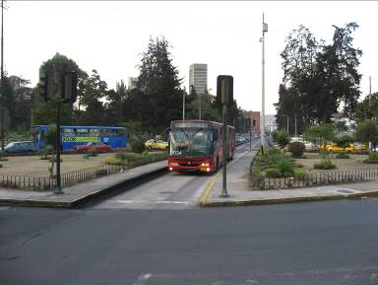

Fig. 24.25 Quito’s Ecovía line cuts directly through a roundabout. Photo by Lloyd Wright.

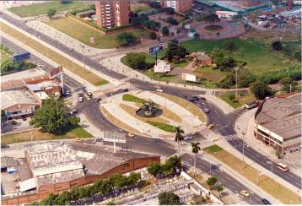

Fig. 24.26 In Cali, the busway also passes through the center of the roundabout area. Photo courtesy of Metrocali.

1. Grade separation

Finally, the most elaborate solution is to construct a busway underpass that goes below the roundabout, and thus avoids all conflicts with mixed traffic. Quito has achieved great success with its “Villa Flor” station that goes beneath the heavily-trafficked roundabout on Maldonado Avenue. Likewise, a series of underpasses near Plaza America in Quito avoid much potential congestion for the city’s Central Norte line (Figure 24.27).As noted previously, while grade separation is potentially the most effective solution in terms of intersection efficiency, its applicability depends on cost and location factors. In some circumstances, underpasses can be quite expensive to construct, although the expected time savings for both BRT users and vehicles can justify such costs. Also, an underpass can complicate station location, especially if there are key destinations near the intersection. Of course, as in the case of Quito’s Villa Flor roundabout, it is possible to locate the station within the underpass itself, which gives customers good access to destinations near the roundabout.

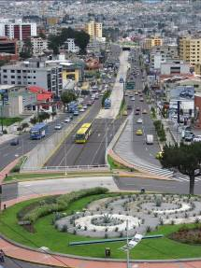

Fig. 24.27 Quito’s Central Norte line uses a series of underpasses to avoid a roundabout near Plaza Américas. Photo by Lloyd Wright.

**24.7 Station Location Relative to the Intersection**

*“*[*The engineer's first problem in any design situation is to discover what the problem really is.*](http://www3.thinkexist.com/quotation/the_engineer-s_first_problem_in_any_design/12265.html)*”*

- Anonymous

Intersection and station design should generally be optimized to minimize the added travel time of the all the customers. The station location in relation to the intersection will affect BRT system flow and speed, pedestrian travel times, and the right-of-way needed for the BRT system. Because conditions vary from intersection to intersection, it is generally advisable to find an optimal solution for each intersection rather than to presume a single solution will always be optimal. The greater amount of information the planning team has available regarding movements and demand, specially pedestrians, the easier it will be to assure this decision for all modes of transport is optimal.

The following station locations are possible:

* At the intersection:
* For side aligned stations, station can be either nearside or far side, i.e. before or after the intersection in each direction;
* For median stations, if not split, station will be near side in one direction and far side in the other.
* Away from the intersection;
* Midblock;
* Under or over the intersection (grade separation).

Stations should in general be around one hundred meters from intersections. Usually the mixed-traffic bottleneck is the intersection, where there capacity is from fifty to thirty percent (proportional to the green fraction of each approach) of mid-block capacity. So if BRT stations are far from intersections, the general-traffic road capacity can be reduced in its surroundings without any significant impact on the capacity and performance on the segment as a whole. This means that mixed-traffic lanes can be removed, and its space given to the BRT station, thus enabling the widening required for BRT at stations to accommodate passing lanes, and hence high capacity at stations, without impacting mixed-traffic capacity.

**Box 24.2 -------------------------------------**

**Calculating the Minimum mixed traffic number of lanes away from the intersection that will not affect segment capacity**

Once capacity in a given control section (FlowCap) is expressed by:

Equation 24.3 (check)

CapFlow = flowperlane_saturation * NLanes * Time_green/Time_cycle

where:

CapFlow:Capacity of the evaluated section of control, usually in pcu/hour

flowperlane_saturation: saturation flow of one free lane, usually around 1800 to 2000 pcu/hour

Time_green/Time_cycle: relative green time

NLanes: number of available lanes

One can evaluate the possibility of narrowing of mixed-traffic road away from intersection without affect the capacity of the segment, by assuring that capacity away from intersection (where relative green time can be considered 1 or 100%) is greater than capacity in the intersection;

FlowCap_away >= FlowCap_intersection

flowperlane_saturation * NLanes_away * 1.0 >= flowperlane_saturation * NLanes_intersection * Time_green/ Time_cycle

NLanes_away >= NLanes_intersection * Time_green/ Time_cycle

Examples:

- if near intersection mixed traffic has 3 lanes (NLanes_away=3), and relative green time is 60% (Time_green/ Time_cycle = 0.6), then far from intersection (Nlanes_away) can be 2 lanes without affecting the segment performace:

NLanes_away >= 3 * 0.6 = 1.8

- if near intersection mixed traffic has 2 lanes (NLanes_away=2), and relative green time is 50% (Time_green/ Time_cycle = 0.6), then far from intersection (Nlanes_away) can be only one lane without affecting the segment performace:

NLanes_away >= 2 * 0.5 = 1.0

End of Box 24.2 -------------------------------------

Box 24.2 -------------------------------------

**Calculating the Minimum Recommended Distance between the BRT Station and the Intersection (from mixed-traffic perspective)**

NOTICE: THIS DISTANCE IS FOR THE DESIGN OF STATIONS THAT TAKES AWAY MIXED-TRAFFIC LANES, NARROWING THE AVAILABLE SPACE FOR CARS AWAY FROM THE INTERSECTION (OR “MID-BLOCK”) ASSURING THAT MIXED-TRAFFIC CAPACITY DOES NOT GET AFFECTED!

Away from the signalized intersection means far enough to guarantee that the capacity flow in the intersection can last all the the green phase. This is equivalent to assure that the qeueing-box (see Box 24.1) with the same number of lanes of the intersection has enough capacity to hold all vehicles that can cross the intersection in the duration of the green phase.

This means the distance from intersection (Dist_station-intersection) has to be longer than the space between to queing vehicles times the number of vehicles that will cross the retention line in one lane.

Considering that a saturation flow per lane (flowperlane_saturation) of 1800 cpu/hour is equivalent to one vehicle each two seconds (across the intersection in one lane) and the distance between (the front of) two vehicles (length_pcu) is 5 meters, this means that for each second of the green phase the queue will be 2.5 meters short.

Queue discharge rate = flow_saturation/lenght_pcu

Another way to think of this is that the “speed of the shock-wave” starting at the retention line when the traffic-signal opens is 2.5 metres per second, i.e., the first car will start to move in the instant the traffic light opens, the car behind (5 meters behind) will start to move 2 seconds after it, the third car behind (10 meters from the retention line) will move after 4 seconds and so on...

Velocity_discharge-shock-wave = flow_saturation/lenght_pcu

Therefore the distance between station and intersection (Dist_station-intersection) has to be equal or greater than the distance the shock-wave can move during the duration green phase (T-gree); representing the speed of shock-wave by Vel_shock-wave, this can be expressed as:

Dist_station-intersection >= V_shock-wave * Time_green

Using meters and seconds for the measures we have:

Dist_station-intersection[in metres] >= 2.5 * Time_green [in seconds]

Examples:

If green time is 40 seconds, the station must be at least 100 meters from the intersection, equal the length of queue discharged during the green time

Dist_station-intersection[in metres] >= 2.5 * 40 = 100

If green time is 90 seconds, the station must be at least 225 meters from the intersection, equal the length of queue discharged during the green time

Dist_station-intersection[in metres] >= 2.5 * 90 = 225

End of Box 24.3 -------------------------------------

Box 24.3 Formulas for calculating the station distance from the signalized intersection.

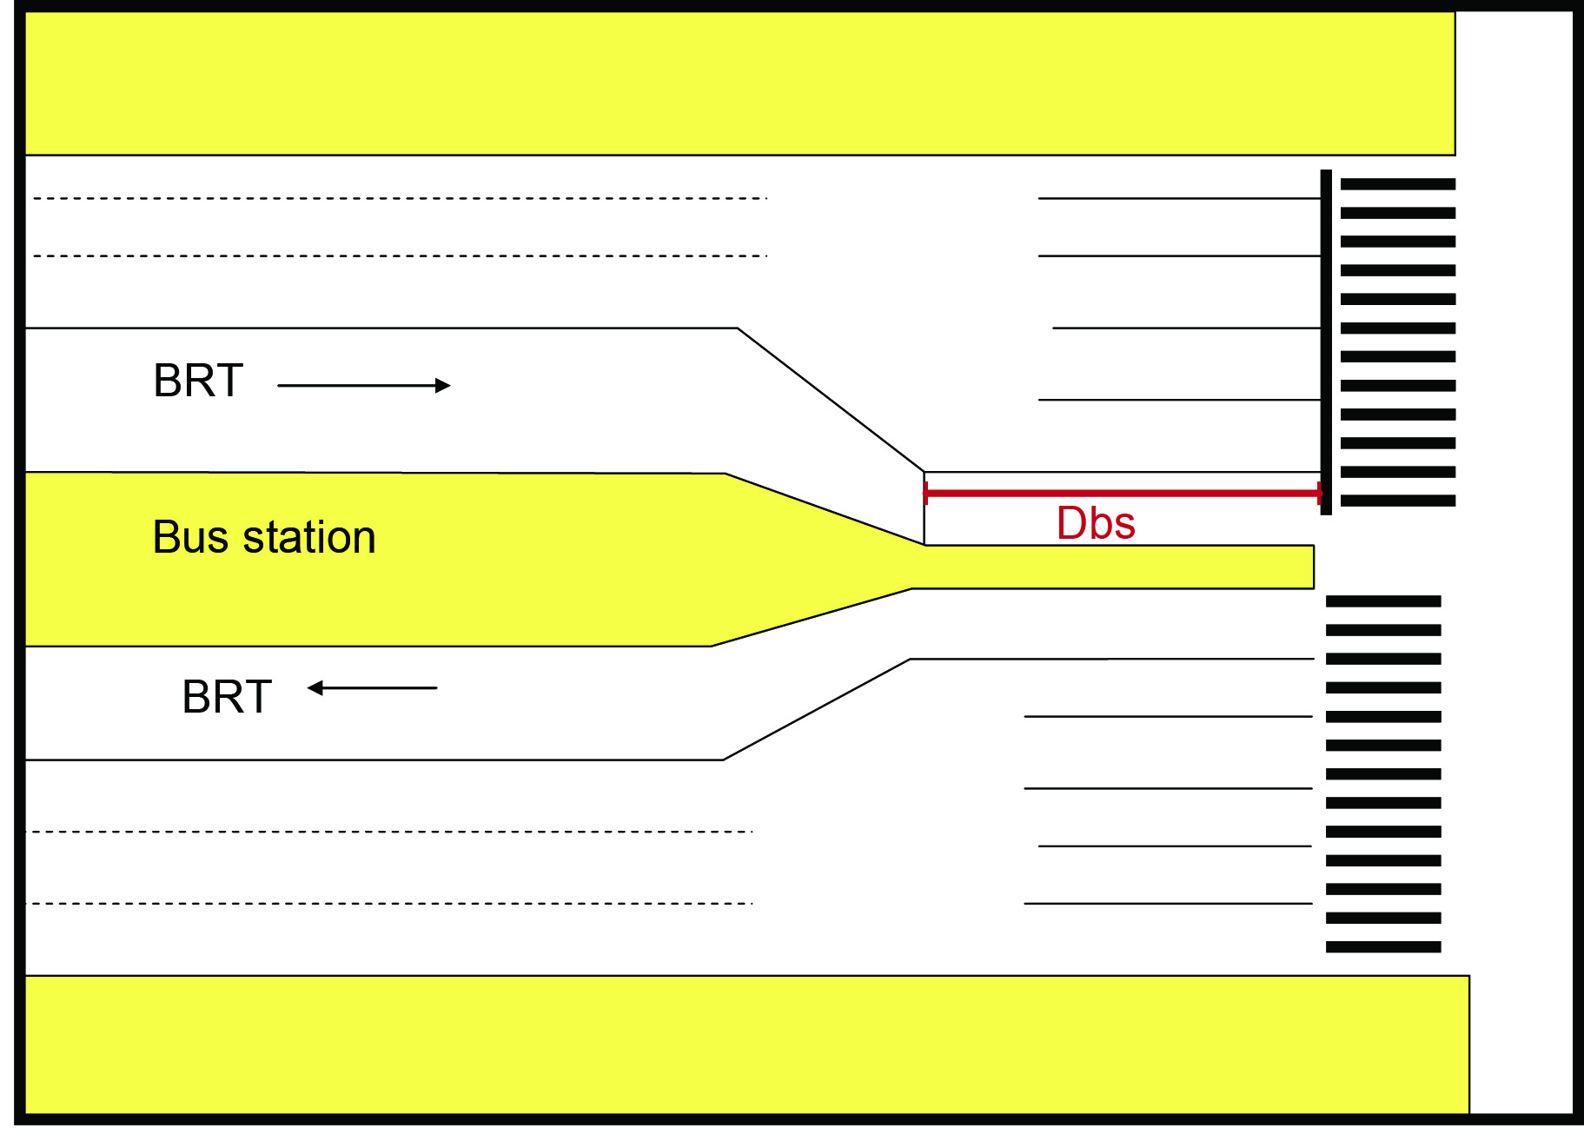

Fig. 24.28 Diagram of the distance between the station and the signalized intersection. Diagram courtesy of ITDP. ←- THIS IS TO RELATE (OR BE INSIDE BOX 24.3)

A comparative evaluation of side-aligned versus median station for each station location type is given in Table 24.1 at the end of this section.

As a general recommendation, BRT systems currently in operation prove that mixed traffic misbehaviour are the biggest source of operation disruptions throughout the public transport system. Traffic spillbacks are commonly seen in heavily congested intersections blocking perpendicular movements along the BRT corridor. Consequently, it is advised to include a safety buffer in the station design for those stations located near a signalized intersection. This additional length will temporarily hold buses that: (1) in case of a blockage have cleared the station but are forced to queue up at the intersection until the conflict is resolved, or (2) have cleared the station during the red phase and have to wait for the green cycle. This buffer should typically be around one hundred meters. A detailed explanation on how to calculate this buffer distance is found in box 24.4.

BOX 24.4---------------------------------

**Calculating the Minimum Recommended Distance between the BRT Station and the Intersection (from BRT perspective)**

This example utilizes data typical of an average city in India.

Nbr= Tr1*Fb/(1 – ( Fb/Sb) ) / 3600

Tr1=50 seconds of red time at intersection

Fb=200 buses per hour passing a particular intersection

Sb=720 articulated buses per hour per lane could pass intersection if the signal were green all the time

Nbr= 50*200/(1 – ( 200/720) ) /3600

= 3.8 buses

Because one cannot actually operate 3.8 buses, “Nbr” must be rounded to the nearest integer, so “Nbr” is equal to 4.

Lb= Length of BRT vehicle + Length of space between vehicles when stopped

= 18.5 meters + 1 meter

= 19.5 meters

Dbs>NBr * Lb

> 4 * 19.5

> 78 meters

Thus, based on the values presented in this example, the minimum recommended distanced between the BRT station and the intersection would be 78 meters.

END OF BOX 24.4----------------------

Box 24.4 Formulas for calculating the minimum recommended distance between the BRT station and the intersection.

**24.6.1 Locating the Stations at the Intersection**

In general, BRT stations should not be located at intersections. If for some reason the stations must be located at the intersection, there is an emerging consensus that near-side location (before the intersection) is preferable in split-platform configurations.

In high-quality “full” BRT systems, a single median station is the ideal solution. Such configurations allow customers to make comfortable platform transfers, and this configuration also greatly simplifies routing options. Furthermore, the construction of a single-median station is generally less costly than constructing two side-aligned stations per direction.

If the median station is placed near an intersection, then the question of before or after the intersection is irrelevant. By definition, the platform of one direction will be before the intersection and the platform of the other direction will be after the intersection. If service frequencies are so low, that congestion for the BRT system is not a concern and mixed traffic flows are low to the point of right-of-way is not scarce , then locating the BRT station at the intersection is not problematic.

**24.6.2 Locating the Stations away from the Intersection**

It is generally recommended to separate the BRT station and the intersection. If the design team is considering placing the BRT station directly at the intersection anyway, the degree of saturation of the busway should be tested on an intersection by intersection basis. In the case of using the preferred single-median station configuration, there is not likely to be any significant pedestrian advantage to an intersection location. In the central areas of a city, midblock destinations may well be as important as intersection destinations.

Separating the station location and the intersection minimizes the risk that BRT vehicles will be backed up at the station, which will inhibit the functioning of the intersection and the functioning of the station. If these two potential bottlenecks are co-located, the risk of mutual interference between the station and the intersection increases (Figures 24.30 and 24.31).



Fig. 24.29 For the direction of the BRT system that stops at the station before the intersection, there is a risk that vehicles will be delayed due to the signal phase. Diagram courtesy of ITDP.



Fig. 24.30 For the direction of the BRT system that stops after the intersection, there is a risk that vehicles create a back-up into the intersection and block traffic. Diagram courtesy of ITDP.

If the BRT system has physically defined stopping bays, like in Bogotá or Curitiba, there is a risk that buses queuing to pass through the intersection will also obstruct the station and passengers will be unable to board and alight until the buses in front clear the intersection. This problem is not as serious in “open” BRT systems without clearly designated stopping bays, but such systems force customers to find their appropriate bus rather than the bus finding the customers. In such systems, customers will have to run up and down the platform to locate and then board their bus.

**24.6.3 Locating the Station Midblock between Intersections**

The principal advantage of placing the BRT station at some distance from major intersections, i.e. midblock, is that it is generally a more optimal way of using a limited right-of-way.BRT systems consume the greatest amount of right-of-way at the station area. This is not only to provide as wide a station platform as possible, it is also sometimes necessary to provide an additional passing lane.

For a BRT system, the main congestion point is typically the station area. For mixed traffic, the main congestion point is typically the intersection. For this reason, it is generally advisable to provide the maximum right-of-way to the BRT system at the station, and the maximum right-of-way for mixed traffic at the intersection. If these two functions are separated, then a fixed amount of right-of-way can be used. The same right-of-way used for dedicated mixed traffic turning lanes at the intersections can be used for passing lanes at the BRT station (Figure 24.31).

As indicated elsewhere in this section, with midblock stations, special facilities for pedestrians to access the station have to be provided, i.e. midblock-signalized pedestrian crossings or grade-separated pedestrian bridges.

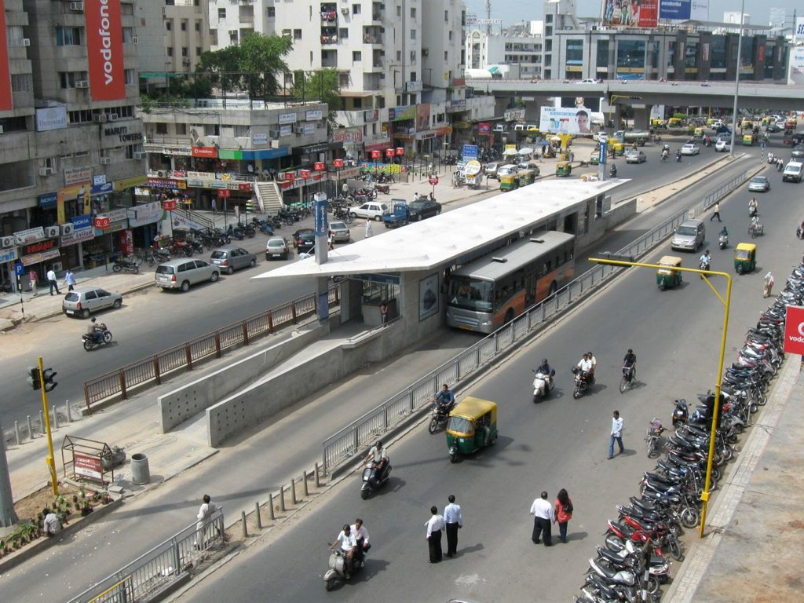

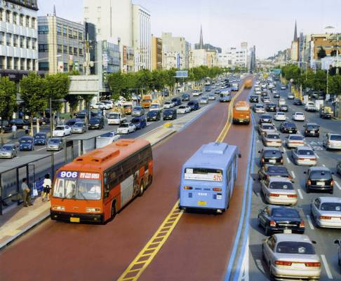

Fig. 24.31 A midblock station location in Seoul allows greater right-of-way width for the station area. Photo courtesy of the City of Seoul.

For example, at the station, if bus frequencies are high and an overtaking lane is needed at each station, the extra width required will be around twelve meters. If the station is located at the intersection, these twelve meters will be difficult to supply while also providing six meters for left and right-turn lanes for mixed traffic. Separating these functions will allow the same right-of-way to be used for the bus station at midblock and for turn signals at the intersection. Figure 24.33 shows an application of this concept in Ahmedabad, India.

Fig. 24.32 In Ahmedabad, midblock BRT stations are given additional right-of-way. However, at the intersections, right-of-way for mixed-traffic vehicles is maximized. Image courtesy of ITDP.

**24.6.4 Calculations for Optimizing the Location of Stations**

* Estimating the level of station-to-traffic signal interference:

Equations24.1, 24.2 and24.3 provide the methodology for estimating the(1) ratio of stopping time to red signal time, (2) busway saturation, and (3) aver

age bus stopping time for two situations.

Boxes---------------------------------------------

**Equation 24.1 Ratio of stopping time to red signal time**

The amount of interference between the station and the intersection depends first of all on the relationship (KR) between the time of the red signal phase (TR) and the average stop time per bus at the bus stop (TB).

**KR = TR / TB**

Where:

KR = the ratio between the average stopping time for buses at the station and the time of the red signal phase

TR = amount of time of red signal phase

TB = average stopping time at the station

As a general rule, the higher the KR value, or the more the red signal time exceeds the average boarding time per bus, the greater the risk that traffic signal interference will saturate the station.

Roughly, the combination of the station’s normal saturation and the additional saturation caused by traffic signal interference will tell one the degree of busway saturation. As a general rule, it is best to design the busway with a saturation level of under 0.4 at the station, meaning that the station is only occupied 40 percent of the time. Equation 24.2 shows how the level of saturation varies with different ratios (KR) of red signal time to vehicle boarding times.

**Equation 24.2 Busway saturation**

**Xsb0 = x * TC / ( TC – TB * KR ) )**

Where:

Xsb0 = Saturation at the station resulting from both normal busway saturation and the signal interference when there is “0” distance between the bus stop and the intersection

x = Normal saturation of the station without signal interference

The factor “x” involves a complex calculation, the derivation of which was illustrated earlier in this chapter. For this section, it will always be assumed that the normal busway saturation has been optimized, and station saturation without signal interference has been kept constant at 0.35, which will rarely congest.

TC= Total cycle time

TB = Average stopping time at the station

The factor “KR” shows that the total saturation of the busway depends not only on the relationship between the total signal phase and the bus stopping time, but also on the relationship between the time of the red signal phase (TR) and the average stopping time per bus at the station (TB). The precise relationship between the bus stopping time, the total signal phase, and the total red time, will vary depending on whether the average bus stopping time (TB) is shorter or longer than the red signal phase (TR), which is reflected in the factor “KR” above.

In equation 24.2, the variables of “TC/(TC-TB)” shows the ratio of the total signal phase to the average bus stopping time. For example, if the signal phase is 60 seconds, and the average stopping time is 30 seconds, then 60/(60-30) is 2. In this case, the total signal phase is twice as long as the average stopping time per bus at the station.

The average bus stopping time TB is derived as indicated in Equation 24.3.

**Equation 24.3 Average bus stopping time**

**TB = X / F * 3600**

Where:

F = Frequency in buses per hour

3600 = seconds in an hour.

Since X has been assumed to be a constant of 0.35, this example produces the following result:

TB = .35 / F * 3600

Finally, the factor “KR” shows that the total saturation of the busway depends not only on the relationship between the total signal phase and the bus stopping time, but also on the relationship between the time of the red signal phase (TR) and the average stopping time per bus at the station (TB). The precise relationship between the bus stopping time, the total signal phase, and the total red time, will vary depending on whether the average bus stopping time (TB) is shorter or longer than the red signal phase (TR), which is reflected in the factor “KR” above.

**Boxes end-------------------------**

*Interference level when bus stopping time is shorter than red signal phase*

The concern about interference is most acute when the bus stopping time (TB) is short and the red phase (TR) is longer, or of similar magnitude. Interference is only of limited concern if the red phase is very short.

Looked at another way, the saturation of the station when the station and the intersection are co-located, will increase in relation to the average time that the boarding and alighting (TB) process overlaps with the green signal phase (Tv).

If the bus stopping time is shorter than the red signal time, then in the most extreme case the station can mostly only function during the green signal phase. For example, in a system with pre-paid platform level boarding, and designated stops for the bus doors, and an intersection with very few passengers boarding and alighting, it is quite possible that the average stopping time per bus could be quite low, as low as 10 seconds. In this case, the risk of interference between the bus stop and the intersection is extremely high.

During the red phase, the bus pulls up, and after only ten seconds, boarding and alighting is completed. After a few seconds, the next bus pulls up behind the first bus, but it cannot board and alight because the station is still occupied by the first bus waiting at the traffic light. A third and a fourth bus may pull up, during which time none of them can board or alight because the first bus is still facing a red signal. In this case, the level of interference between the signal and the bus stop is at a maximum.

Therefore, if

TB < TR

Then:

Xsb0 = x * TC / (TC – TR + To)

Where:

Xsb0 = Saturation at the station resulting from both normal busway saturation and the signal interference when there is “0” distance between the station and the intersection

x = Normal saturation of bus stop without signal interference

TC = Total cycle time

TR = Total red time

To = The average time that the boarding and alighting process overlaps with the red signal phase

x = 0.35

If the bus stopping time is less than the red time at the traffic light, the impact of the conflict between the signal and the station on the system’s saturation can be estimated by assuming that half of the boarding time will take place during the red time and half will take place during the green time. This assumption will not be exact, but it will give a good indication of the risk of saturation.

Mathematically, therefore,

To = 0.5 * TB

Where:

0.5 = the probability that boarding and alighting will take place during the red phase.

TB = x / F * 3600

In this case, calculating the saturation of the station when faced with interference from the traffic signal, the following formula can be used:

Xsb = x * TC / ( TC - TR + (0.5*TB) )

Since the equation varies depending on the ratio of red time to stopping time (KR), the equation below shows how KR enters into the equation:

Since KR = TR/TB, then TR = TB*KR, so the above formula can also be written as follows:

Xsb = x * TC / [ TC- (TB * KR) + (0.5*TB) ]

Therefore, for the conditions in which the boarding and alighting occurs half during the red signal phase and half during the green signal phase, Equation 8.19 becomes:

Xsb = x * TC / ( TC - TB * (KR - 0.5) )

Box 24.1 provides an example of applying this equation for conditions in which there is a short boarding and alighting time relative to the read signal phase.

**Box 24.3 Calculating station to intersection interference with a long red phase cycle**

In this example, the red phase cycle time is relatively short when compared to the vehicle stopping time.

TR = 15 seconds of red phase

TB = 40 seconds of vehicle stopping time

TC = 30 seconds full signal phase

x = .35

**Xsb0= .35 * 30/(30-152/ ( 2*40) )**

= 0.386

In this case, because the red phase is quite short, there is fairly minimal risk that the traffic signal will disrupt the functioning of the bus stop, so saturation increases only marginally, from 0.35 to 0.386.

**box**

his example assumes that the vehicle stopping time occurs equally between the red and green signal phase.

Xsb0 = x*TC/( TC-TR+ (0.5 * TB) )

x = 0.35

TC=700 seconds of total cycle time

TR= 500 seconds of total red time

TB = 10 seconds (average bus stopping time)

Xsb0 = 0.35 * 700 seconds / ( 700 seconds – 500 seconds + 0.5 * 10 seconds )

= 1.195

TIn this hypothetical example the station would operate on just the 200 seconds of green, but not on the 500 seconds of red, because just some seconds after the red phase begins the bus will finish boarding, but it will obstruct access to the bus stop during the entire 500 seconds of red.

**Thus, at a value of 1.195 the high saturation leads to considerable congestion of the busway.**

**Box 24.4 Calculating station to intersection interference with a short red phase cycle**

* Optimization of station location when walking time is included

Optimizing station location in terms of pedestrian-walking times is location-specific, as it depends on the location of popular pedestrian destinations, the boarding and alighting passenger volumes, the passenger transfer volumes, the location of allowed pedestrian crossings, and the structure of the signal phasing.

If the situation is optimized to include walking times, it is quite probable that along a BRT corridor, some stations would be located at midblock, others at the intersection, and still others adjacent to major trip destinations. Furthermore, some compromise between pedestrian-travel times and the vehicular-travel times can generally be found. Stations do not need to be in the middle of the block to avoid interference with the intersection; they just need to be far enough away to avoid the conflict.

* Calculating the minimum distance to avoid station – intersection conflicts

It is useful to calculate the minimum distance that will avoid any likely conflict between BRT-vehicle movements at stations and mixed-traffic movements at intersections. The minimum distance can be simply determined by the amount of space required for queuing BRT vehicles.

Equations 24.4, 24.5 and24.6 provide the methodology for estimating (1) the maximum distance between stations and intersections, (2) the number of BRT vehicles queuing at the intersection and (3) distance at which intersection conflicts occur.

**Equation 24.4 Calculating the minimum distance between stations and intersections**

Dbs>Nbr * Lb

Where:

Dbs = Distance from the BRT station to the stop line of the nearest traffic signal

Nbr = Likely number of BRT vehicles to queue during the red phase of the traffic light

Lb = Average length of lane space consumed by the queuing BRT vehicles

The factor “Lb” consists of two factors: 1. Length of the BRT vehicle (L); and 2. Length of space between BRT vehicles when stopped (usually assumed to be 1 meter).

Equation 24.5 is then used to derive the number of BRT vehicles that will queue at the signal.

**Equation 24.5 Number of BRT vehicles that will queue at the signal**

Nbr = Tr1 * Fb / ( 1 – ( Fb / Sb ) ) / 3600

Where:

Tr1 = Amount of red time placed on the BRT vehicles at intersection

Fb = BRT vehicle frequency per hour at the intersection

Sb = Bus lane capacity (usually 720 articulated buses/lane/hour or 950 standard buses/lane/hour)

3600 = seconds in an hour

Box 24.3 provides an example of calculating the minimum recommended distance between the BRT station and the intersection.

Box 24.5 provides an example of calculating the minimum recommended distance between the BRT station and the intersection.

**Box 24.5 Calculating the minimum recommended distance between the BRT station and the intersection**

This example utilizes data typical of an average city in India.

Nbr = Tr1 * Fb / ( 1 – ( Fb / Sb ) ) / 3600

Tr1 = 50 seconds of red time at intersection

Fb = 200 buses per hour passing a particular intersection

Sb = 720 articulated buses per hour per lane could pass intersection if the signal were green all the time

Nbr = 50 * 200 / ( 1 – ( 200 / 720 ) ) / 3600

= 3.8 buses

Because one cannot actually operate 3.8 buses, “Nbr” must be rounded to the nearest integer, so “Nbr” is equal to 4.

Lb = Length of BRT vehicle + Length of space between vehicles when stopped

= 18.5 meters + 1 meter

= 19.5 meters

Dbs>NBr * Lb

> 4 * 19.5

> 78 meters

Thus, based on the values presented in this example, the minimum recommended distanced between the BRT station and the intersection would be 78 meters.

**Equation 24.6** Calculating the distance at which intersection conflicts occur

**Equation 24.6** Calculating the distance at which intersection conflicts occur

D12 < 3 * Max ( Tg1, Tg2 )

Where:

D12 = Distance between intersection 1 and intersection 2

Tg1 = Green signal time per phase cycle at intersection 1

Tg2 = Green signal time per phase cycle at intersection 2

A mixed traffic lane can generally handle 1,800 vehicles per hour. This quantity translates to two vehicles per second (3,600 seconds in an hour). When vehicles are stopped at a stop light, the average amount of space they take up is 6 meters; this space includes the vehicle and some space between vehicles. This average vehicle distance means that for each second of time, 3 meters of vehicle-equivalents can be moved through the intersection.

Box 9.4 provides a sample calculation of the required spacing between two intersections.

**Box 24.6 Calculating vehicle queues between intersections**

The following scenario is outlined in order to determine whether two intersections will result in free-flow operation or in congestion:

D12 = Distance between intersection 1 and intersection 2

= 100 meters

Tg 1 = Green phase time at intersection 1

= 40 seconds per phase

Tg 2 = Green phase time at intersection 2

= 30 seconds per phase

To determine if the distance between these intersections is sufficient, Equation 9.12 can be applied:

D12 < 3 * Max ( Tg1, Tg2 )

100 meters < 3 * 40 = 120 meters

Since 100 meters is less than the required 120 meters, there is not enough space between the intersections. It is therefore possible that vehicles queuing at the second light will back-up onto the first intersection. Since intersection 1 has a green phase of 40 seconds, some 20 vehicles will clear the intersection. As each vehicle on average consumes 6 meters of longitudinal space, 120 meters of vehicles will form a queue at the second intersection. If the intersection is only 100 meters away, then the queue will spill over into the first intersection and disrupt the functioning of the first traffic light.

* Optimizing station location when intersections are close together

Mixed-traffic vehicles will most likely be able to pass through the two intersections using a synchronized signalization system. However, the same may not be true for BRT vehicles. Instead, the BRT vehicle will pass through the green phase at the first intersection and then stop at the station for passenger boarding and alighting. By the time the vehicle resumes movement towards the second intersection, the signal phase may well have changed to red (Figure 24.34). Thus, this configuration may lead to considerable delay for public transport passengers.

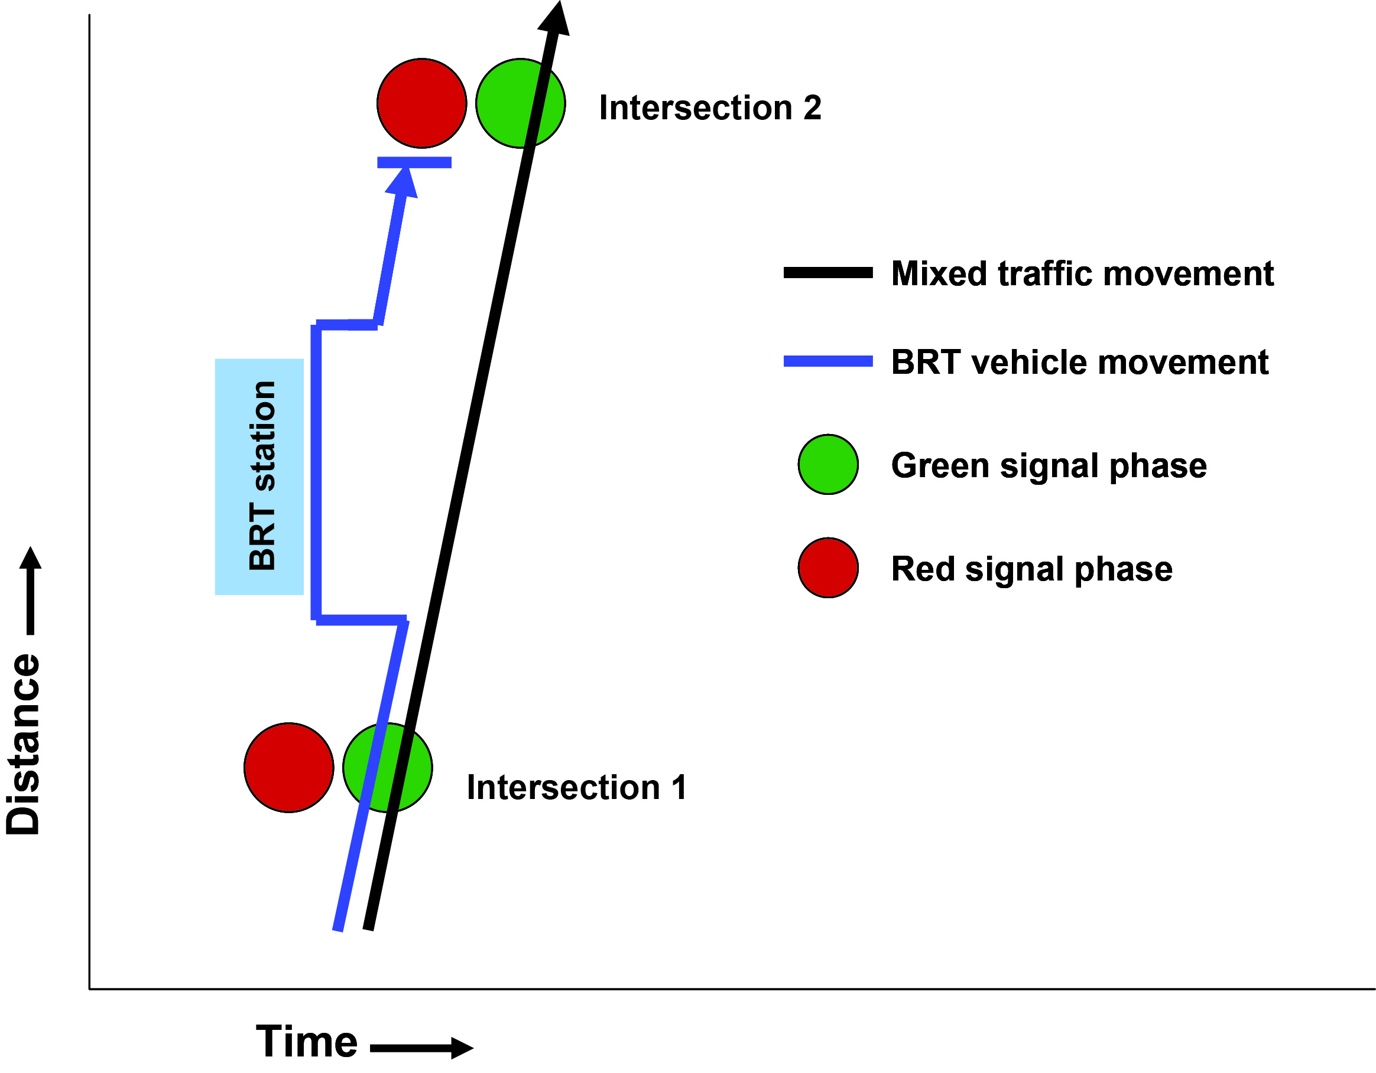

Fig. 24.33 While mixed traffic vehicles may benefit from a synchronized green phase between two intersections, BRT passengers may encounter the red phase at the second intersection. Diagram courtesy of ITDP.

Even for normal mixed traffic, having two intersections too close together will sometimes lead to problems. Vehicles queued at one intersection will back up to the point where vehicles are unable to clear the previous intersection during a green phase. Equation 24.7 provides a methodology for calculating the distance at which this type of conflict may occur.

**Equation 24.7** Calculating the optimum distance for terminating the busway

L (meters) = ~3 * Tv (seconds)

Where:

Tv = Green phase time for the BRT approach

This calculation, however, no longer works if the facility itself also becomes congested. If there is a risk that the bottleneck facility itself may become congested, a special signal should be used. This signal would generally flash yellow until the point where traffic detectors note that the critical link has itself become congested. At that point, the signal would be activated, and a red signal would be given to mixed traffic until the bottleneck clears (Figure 9.57). The selective use of such a traffic signal will help to avoid congestion inside the busway. Instead the delay is transferred to the mixed traffic in the previous link, resulting in improved velocity for BRT vehicles at the critical link. For tunnels, this approach has the extra advantage of avoiding idling vehicles within heavily polluted conditions.

This formula assumes uniform arrivals, but Poisson arrivals can also be employed.

**24.6.5 Locating the Station under or over the Intersection (Grade Separation)**

As noted earlier, putting the busway on a separate grade at intersection locations brings with it many benefits from the perspective of travel-time savings. A BRT tunnel or overpass can improve intersection capacity for both BRT vehicles and mixed-traffic vehicles. A BRT tunnel will free up surface space that can be utilized for mixed-traffic turning lanes.

However, grade separation brings with it two complications. First, the infrastructure can be costly, depending on local circumstances. In many instances, the time savings to BRT passengers and to private vehicles will fully justify the added infrastructure costs, but limited capital resources will typically constrain infrastructure expenditures.

Second, grade-separation can limit the location of the stations, making them further apart than is desirable. The Quito Central Norte line uses grade separation quite effectively with tunnels, whisking BRT vehicles through congested intersection locations. However, the tunnels also imply that at important destinations, such as the Plaza de las Américas, the closest station is a considerable distance away (Figure 24.34).Thus, from a customer perspective, the time savings from the grade separation can be essentially lost due to the longer walk to access the intended destination.



Fig.24.34 In the case of Quito’s Central Norte line, the presence of a BRT underpass has meant that the closest station to a key destination, the Plaza of Américas commercial center, is several hundred meters away. Photo by Lloyd Wright.

As an alternative to this conflict between intersection efficiency and convenient station location, it is possible to place the station beneath the intersection. In this case, both the time savings of grade separation is gained as well as a convenient station location to key destinations. Many underground metro stations utilize station siting in this manner. The Metro Center station of the Washington Metro exits directly into the basement floors of commercial shops. In such cases, though, accessing ground-level shops and offices will require a grade transfer for customers, implying stairs, escalators, and/or elevators. Likewise, both the Brisbane and Ottawa BRT systems site stations at the tunnel level. In Brisbane, the station is just before the tunnel, and thus provides good customer access to local destinations.

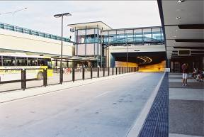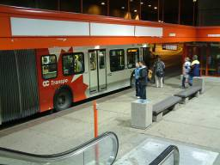

|  |  |
| --- | --- |
|  |  |

Fig. 24.35 and 24.36 Placing stations just before a BRT tunnel, like in Brisbane, Australia (left), or even within the tunnel, like in Ottawa (right) helps customers with comfortable access to local destinations. Left photo courtesy of Queensland Transport. Right photo by Lloyd Wright.

**24.7 Traffic Signal Control and Intersection Layout**

*“A common mistake that people make when trying to design something completely foolproof is to underestimate the ingenuity of complete fools.”*

- Douglas Adams, novelist, 1952 - 2001

**24.7.1 Traffic Signal Control**

Generally, arterials have fairly high turn movements at major intersections. After the introduction of the BRT lanes, these movements need to be accommodated, especially if restricting left turn movements cannot be achieved.

The three most common options for the traffic-signal control at major intersections are as follows:

* One stopline, restrict left turn movements: Generally this option leads to the diversion of traffic through the adjacent street system, as vehicles use other routes to get to their ultimate destination (as seen in section 24.4.2);
* One stopline, accommodate BRT/normal vehicle left-turn movements in separate phases: This option can be used where space is not a constraint and the number of lanes for private vehicle and BRT movements can be accommodated. Higher delays are observed as a consequence of more active phases at the intersection;
* Pre-signal stopline, where vehicles are held back to allow buses to approach stopline in advance of normal vehicles, and thereafter normal signal phasing applies: This option is generally used where there are space constraints and the number of lanes required for turning cannot be accommodated.

A fourth traffic-signal control strategy is to introduce a protected u-turn phase for general traffic on the major approaches, while at the same time restricting left turns. In this instance, vehicles turn out of what is usually the exclusive left-turn lane prior to the pedestrian crossing at the approach, thus making use of the same green time as allocated to the through vehicles (and also pedestrians) on the crossing road. U-turning vehicles thereafter travel back along the major route to turn right into the crossing road one block before. This strategy, intersection layout, and associated turn movement restrictions have been used very successfully in Guangzhou, China.

It should be noted that the authority responsible for the ongoing control and maintenance of the signal system implemented as part of the introduction of the busway must work closely with the authority responsible for the operation of the busway system. If there is not cooperation between these two authorities, serious operating problems can arise, which can negate the benefits of the introduction of the busway.

**24.7.2 Intersection Layout**

The definition of a general layout depends on expected vehicle and BRT movements and flows through the intersection and the resultant number of lanes required to accommodate these movements. The space available for upgrading the intersection generally dictates the signal-control strategy adopted for the intersection.

The layouts of two intersections described below are for: (1) where space is adequate and all required movements (mixed traffic and BRT) can be accommodated, and (2) where space is limited and a pre-signal control strategy has been adopted. It should be emphasized that these are only two examples of many different situations.

* Intersections widened to accommodate all movements where space is adequate (Figure 24.37)

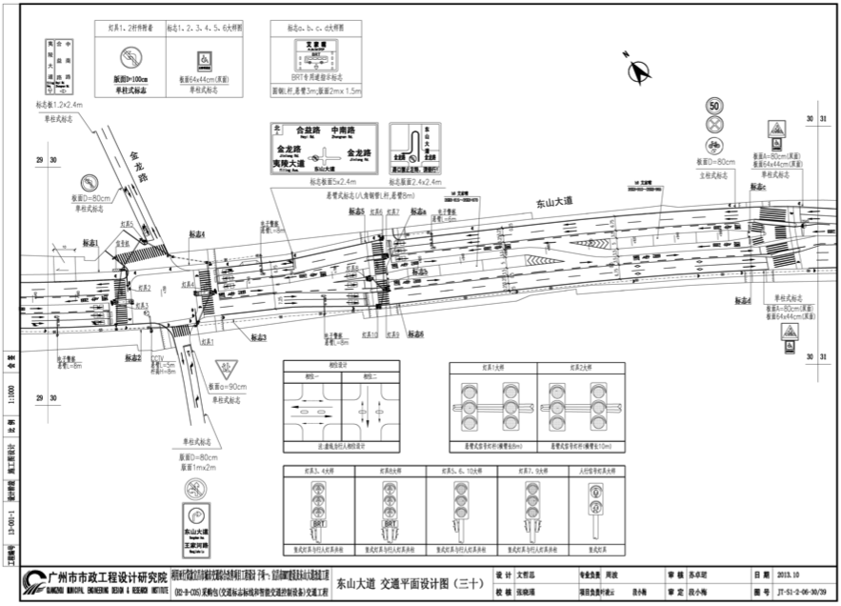

Fig. 24.37 Typical intersection layout for a BRT station and intersection in Yichang. Note the BRT station located away from the intersection, the two phase intersection, and how having the station away from the intersection results in provision of more pedestrian crossings than would otherwise be provided. Diagram courtesy of GMEDRI; planning and design by ITDP and GMEDRI.

In Cape Town’s BRT system, where there is sufficient width at a major intersection, a single stop line is used on the major approaches, and general traffic right-turn movements are accommodated in exclusive turn lanes by means of protected turn phases. No permissive right-turn movements are allowed; and BRT through movements are accommodated simultaneously with the mixed-traffic through movements.

In order to accommodate the signal-control aspects at the nearside and far side of the stop line, splitter islands are introduced to accommodate the traffic-signal poles for mixed-traffic as well as for BRT vehicles. These splitter islands have a minimum width of 1.2 meters on the nearside and 1.6 meters on the far-side, to accommodate the traffic-signal heads for the through and right-turn movements.

If there is a BRT station at the intersection and there is a passing lane at the station, then the width of the BRT lanes will be a minimum of 6.5 meters passing the station. The width of the BRT lane at the stop line will be approximately 5.3 meters at the stop line, depending on the width of the nearside splitter island. On the far side of the intersection, the BRT lane will revert to a single lane (minimum width of 3.5 meters), and the splitter island will generally be about 3-meters wide.

It’s sometimes useful to provide a complete two-lane layout continuous from the station until the stop line (7-meters wide). Transition from two-way to single lane could start from the stop line and extend to the other side. In some cases, and if space is available, it’s convenient to continue with two BRT lanes after the intersection, leaving enough space for two buses at the intersection. This is helpful in heavily transited corridors with occasionally congested intersections.

Where right-turn (or left turn for Cape Town’s case)movements are high and there is sufficient road reserve width at the intersection, separate free flow (channelized) right-turn slip lanes can be provided, with curbed islands separating the right-turn movement from the through movement. This island provides refuge for pedestrians who will require a signalized pedestrian crossing across the slip lane. The right-turn movement is generally free flow (other than when there is pedestrian demand), provided there is sufficient capacity downstream on the crossing road. If not, then the movement will be yield-controlled or even signalized.

* Intersection with pre-signals where space is limited

Where there is insufficient space to accommodate the required number of mixed-traffic and BRT lanes at the intersection, a pre-signal layout can be adopted where the bus lane is terminated sixty to seventy meters before the intersection. In this instance, there are two stop lines for the major approaches at the intersection, a normal stop line for all vehicles at the intersection itself, and separate pre-signal stop lines for BRT vehicles and mixed traffic where the bus lane is terminated.

The bus lane at the pre-signal stop line will receive a bus-only green signal, eight to ten seconds prior to the adjacent mixed-traffic lanes, to enable it to leave the bus lane and proceed to the second stop line at the intersection. Thereafter, mixed traffic at the pre-signal stop line is given a green signal, as are all vehicles at the second stop line at the intersection itself. This allows BRT vehicles to re-enter the bus lane after the intersection, mixed-traffic vehicles to pass through the intersection, and left-turn vehicles to stack in the left-turn lane(s) for priority left-turn movements, followed by a protected right-turn phase to clear the area between the two stop lines.

Fig. 24.38 and 24.39 Typical intersection with shared stop lines (left); and pre-signals for buses and normal vehicles in Cape Town, South Africa (right). Photos by Bruce Sutherland.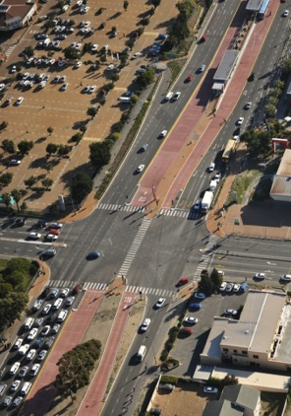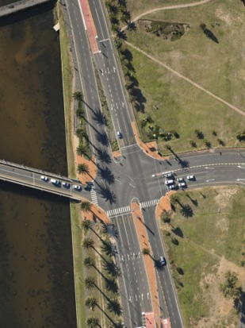

* Intersection with restricted turn movements

Where turn movements are judged to be inconvenient and the intersection is simplified to a two-phase scheme, a standard layout with a single stop line is commonly adopted for all the approaches. A similar transition from two BRT lanes to a single one, as explained in Figure 24.41 can be implemented.

Fig. 24.40 Intersection layout with restricted turn movements with dual BRT lane at approach in Brisbane, Australia. Photo byKarl Fjellstrom.

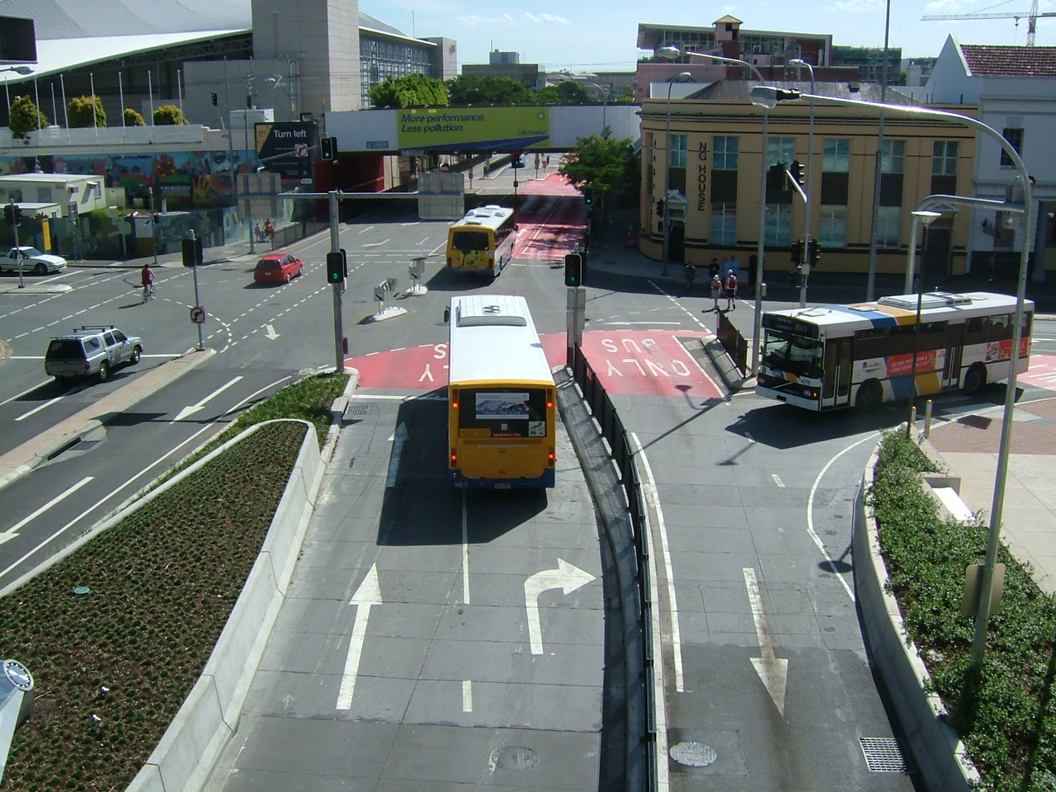

Fig. 24.41 Double to single BRT land transition before intersection, in Guangzhou, China. Photo by Karl Fjellstrom. Similarly, with the previous layouts, the right-turn movement is generally free flow (other than when there is pedestrian demand), provided there is sufficient capacity after the crossing road. If not, then the movement will be yield-controlled or even signalized.

Once the strategy for accommodating the BRT lanes/movements at the intersection has been decided, an assessment of the performance of the intersection for the future situation must be carried out.

**24.7.4 Location of Detection Loops**

Detection loops for conventional signalized intersections are generally placed at the stop line, at the start of the left turn lane (when the lane width fully developed after the taper length), and also at a position 120meters upstream of the stop line. The first set of loops at the stop line is for vehicle detection, while the second set, located in the exclusive left turn lane and 120meters upstream, is for monitoring the flow of vehicles (demand) approaching the intersection. This provides information for an area wide or corridor specific, demand responsive traffic control system such as SCOOT, normally found in cities in developed countries.

In the case of an intersection with pre-signals, the vehicle detection loops are placed at the first and second (pre-signal) stop lines. The SCOOT loops are then placed 120meters upstream of the pre-signal stop line and 40meters upstream from the intersection stop line in the exclusive right turn lane/lanes.

**24.7.5 Signal Priority**

Traffic-signal priority for BRT vehicles can take one of two forms:

* *Passive signal priority:* the adjustment of normal traffic signals to give priority to a corridor with a BRT system over a corridor without one, and to give priority to the BRT system over mixed traffic within that corridor.
* *Active signal priorit*y: needs to be activated by electronic equipment that detects the arrival of a BRT vehicle at an intersection and adjusts the traffic signal accordingly.

**24.7.5.1 Passive Signal Priority**

Passive signal priority should always be a basic first step in giving a BRT system traffic-signal priority in a given corridor. Signal priority is quite complementary to the signal phase simplification discussed earlier, and thus the two techniques can be considered jointly for implementation.

One of the most basic measures within passive signal priority is to give BRT corridors preference over cross streets that do not have public-transport services. This prioritization can be achieved by extending the green time for the BRT corridor over the cross street. This action will improve the travel speeds of all the traffic (both bus and mixed traffic) on the BRT corridor at the expense of all the traffic on the non-BRT corridor.

The next step is generally to see if the signal phases on the BRT corridor can be shortened. Because BRT vehicles are less frequent than mixed-traffic vehicles, they are more adversely impacted by long signal phases than mixed traffic. The actual optimal-signal phase will depend on both the flow of BRT vehicles and the flow of mixed traffic.

It is not unusual for total cycle time on a BRT corridor to be as low as 60 to 90 seconds, rising to as high as 120 seconds or longer only at major intersections or during peak hours, and mainly to extend the green time within the BRT corridor. On a BRT corridor, the red time faced by the BRT system should be as close as possible to 50 percent of the total signal cycle. It is typical for the BRT green time to be 30 seconds in a 60 second cycle, or 40 to 60 seconds on a 120 second cycle.

Synchronization of green-signal phases between intersections is not common with BRT systems. Since BRT boarding and alighting times can be somewhat irregular, determining the signal timing between intersections is quite difficult. If BRT vehicle speeds are reasonably predictable, and intersections are less than 1.6 kilometers apart, it may be possible to coordinate traffic lights in a BRT corridor. This practice is used in Ottawa. As stated earlier in this section, close co-operation is required between the authority responsible for operation and maintenance of the traffic signal system and the authority operating the busway, to ensure that optimal benefits are achieved for all vehicles using the system.

**24.7.5.2 Active Signal Priority**

Active, or real-time priority techniques, change the actual traffic-signal phasing when a BRT vehicle is observed to be approaching the intersection (Figure 24. 42.At an even higher level of sophistication, the priority phasing can be based on observed traffic levels for both BRT vehicles and general traffic. The importance of traffic-signal priority on BRT vehicle speeds tends to be greatest in systems with fairly low bus volumes, particularly with bus headways longer than five minutes. When BRT vehicle headways are less than 2.5 minutes, it is generally difficult to implement active signal priority at all. If signal phasing were attempted with such high-frequency, the non-BRT traffic direction would essentially be in a state of a permanent red phase, although applying the signal priority to alternating phases would still be possible.

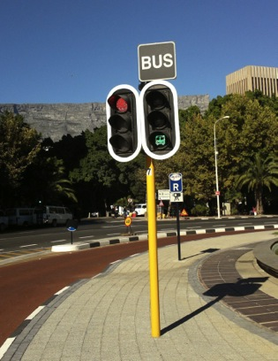

Fig. 24.42 Active signal priority for BRT can do much to improve public transport travel times. Photo by John Jones.

Because most BRT systems to date have been developed in developing countries with high bus frequencies and relatively few intersections, most of the famous BRT systems have relied primarily on turning restrictions to increase intersection efficiency, and not sophisticated real time signaling systems. With an exclusive bus lane and an optimized station design, the additional benefits for BRT vehicles resulting from highly technological signaling systems may be small relative to the cost of the signaling equipment. However, as vehicle detection, signaling equipment, and priority software have become increasingly common, the costs are becoming increasingly affordable.

For traffic systems where flows are quite irregular, real-time control systems that weigh signal times to observed traffic levels can yield benefits. In such real-time systems, phase changing is usually based on a trade-off between the benefits and costs faced by the green and red approaches. Special weight can be given to BRT vehicles or to the BRT corridor. For the general principle of shortening red times, a fully actuated system based on total vehicle movements, which also includes BRT vehicles, is probably more important than BRT-specific detection. The green times are likely to be most easily extended at intersections with light cross traffic.

**24.7.6 Special Turn Movements Using Vehicle-Activated Signals**

A possible important use for vehicle-activated signals is for special turning movements on and off the BRT corridor. If an intersection has a small number of BRT routes that need to turn left, a special left-turn phase can be added to the cycle upon the detection of an approaching BRT vehicle. When the turning movement does not have a special lane, GPS or similar, individual bus detection technique may be needed. These kinds of activated systems for special turning movements can save up to thirty percent of signal delay, not only for the BRT system but also for general traffic.

Real-time activation of signals can also be used on specific critical bottlenecks along a BRT corridor. For example, sometimes a BRT system must pass through a narrow stretch of road that is impossible to widen. Such areas may include bridges, tunnels, city gates, or flyovers. Usually the heaviest congestion occurs not on the critical link but just before it, forming a large queue just to enter onto the bottleneck point.

When only the approach to the facility and not the facility itself is congested, a traffic signal is generally not needed, and it may be better to end the exclusive busway just a short distance before the bottleneck. The distance should be sufficient only to allow a convenient distance for merging (forty to eighty meters).This curtailment of the busway will allow BRT buses to pass through most of the congestion point without provoking any reduction of mixed-traffic capacity at the critical section (Figure 24.43).

Fig. 24.43 In the case of a severe bottleneck point, it may be best to terminate the exclusive busway prior to reaching the bottleneck. Diagram courtesy of ITDP.

If the critical link is an approach to signalized intersection, the BRT lane should finish at a given distance. Equation 24.44 the calculation for determining the optimum distance for terminating the exclusivity of the busway.



Fig. 24.44 If the bottleneck area itself is congested, then traffic signal control, with active priority for BRT vehicles, may be an appropriate solution. Diagram courtesy of ITDP.

The example given in Figure 24.44 essentially acts as a queue-jumping mechanism in which the BRT vehicles are given an advantage through a bottleneck point.

**24.7.7 Pedestrian and Cyclist Crossing Considerations**

A highly efficient intersection for mixed traffic and BRT vehicles may not be user-friendly to other street users, especially vulnerable users such as pedestrians and cyclists. Furthermore, the entire viability of the BRT system can be undermined if the surrounding pedestrian environment is not amenable to attracting customers to the BRT station. This section examines design options that are not only conducive to effective vehicle movements at intersections, but also options that successfully accommodate pedestrian and cyclist movements.

A standard two-phase traffic signal configuration does not offer any exclusive movements for pedestrians (Figure 24.45).In both phases, crossing or turning traffic blocks pedestrians. In such circumstances, the pedestrian must seek a discernible break in the traffic and make a quick crossing. Obviously, such conditions put pedestrians at considerable risk.



Fig. 24.45 In a standard two-phase traffic signal, pedestrians are potentially at risk during both phases. Diagram courtesy of ITDP.

The lack of safe pedestrian options can also be the case for three and four-phase intersections, depending on the configuration. If intersections are designed to slow turning vehicles, and if turning vehicle volumes are not that high, the problem may not be serious. However, if turning volumes are high or intersections allow high speed right turns, bicyclists and pedestrians going straight will have problems crossing the road.

The normal solution to this problem is the creation of a pedestrian refuge island between the right turn slip lane and the intersection and not allowing right turns during the red-signal phase (Figure 24.46).Pedestrians can generally cross to this pedestrian refuge island during the red phase, and then cross when the light turns green. For these cases, a stopping line for right turns is needed; otherwise, with this lane configuration, enforcement of right turning vehicles on red will be difficult in less-developed countries. Traffic calming for these movements is then recommended. Another possible solution for this is a short “leading pedestrian interval” that allows pedestrians to cross in front of right turning vehicles prior to the change of the signal to green. This option still requires disallowing right turns on the red signal but mitigates the need for the pedestrian refuge island. More discussion on safe pedestrian access is included in Chapter 28: Multi-Modal Integration.



Fig. 24.46 The introduction of a pedestrian island between the right-turn lane and the crossing can significantly help pedestrians safely cross within the standard two-phase traffic signal. Diagram courtesy of ITDP.

For cyclists, intersection risks often emanate from turning vehicles that threaten straight movements by the cyclists. Since the motorized vehicles are often travelling much faster than the bicycles, there is a great potential for conflict and risk at turning locations. Cyclists may feel particularly vulnerable when wanting to turn left (or right in a British-style configuration).

There, are at least two mechanisms for permitting cyclists to safely navigate intersections:

* Infrastructure giving physical priority to cyclists and allowing them to cross prior to private vehicles; and/or,
* Dedicated signalization for cyclists.

In several countries, dedicated areas located in front of the stopping line for motorized vehicles (commonly called “bike boxes”) have been an effective option (Figures 24.47 and 24.48).The idea is to give cyclists a head start over motorized vehicles in crossing the intersection. The cyclists are given a designated box to wait for the green signal phase. In some cases, this physical priority can be combined with a dedicated signal phase as well.

|  |  |
| --- | --- |
| xian-kf-06-aug-04+116 | London, UK, Bicycle box, Aug 2003 |

Fig. 24.47 and 24.48 In Chinese cities such as Xi’an (left), cyclists are given designated waiting areas from which they have priority access to crossing the street. Likewise, in the UK (lower photo), a priority bicycle stopping area (bike box) is placed ahead of the stopping line for motorized vehicles. Left photo by Karl Fjellstrom. Right photo by Lloyd Wright.

Fig. 24.49 Schematic of the dedicated waiting area utilized by cyclists wishing to make left turns in Xi’an. Diagram courtesy of ITDP.

Dedicated signal phasing for bicycles is increasingly common, especially in the presence of a median bike lane. Bike lanes in Bogotá and Rio de Janeiro make use of such signalization, as do many cities in Europe. A dedicated green phase for bicycles gives cyclists an added sense of security.



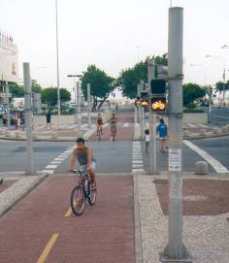



Fig. 24.50 A dedicated green phase for crossing cyclists is another effective solution, as shown in this example from Rio de Janeiro. Photo by Lloyd Wright.

The addition of a median busway does make for an added complication, but it is still quite possible to adequately accommodate safe cyclist movements and maintain a high-volume public transport system. One option is to place both a dedicated busway and a dedicated bike lane in the median area. Figure 24.51 shows how a standard two-phase signal could be combined with dedicated wait areas for turning bicycles in order to make both BRT and bicycle movements safe and efficient.

Fig. 24.51 A median bike lane and median busway can be an effective solution to provide safe and efficient movements for both modes. In this case, a priority-wait area for bicycles helps cyclists get a head start over motorized vehicles when negotiating a turn. Diagram courtesy of ITDP.

Other possible roadway configurations are also possible. Bike lanes along the curbside are common in many cities. Detailed information on this topic is available in Chapter 31: Bicycle and Pedicab Integration and other bike-planning manuals.